

Iqueue Project

Feasibility Study

Software Engineering for Automation (2022-2023)

Giacomelli Gianluca, 10615105 Professors: Rossi Matteo Giovanni

Gottardini Andrea, Codice persona Lestingi Livia

Veronese Niccolò Enrico, 10620278

Summary

Project Description 2

Experimental Setup 2

Transient Regime Analysis 2

Time-histories 2

Dispersion relation 6

Steady-State Analysis 8

Frequency Response Functions 10

Modal Shapes 15

Control Strategies 20

Passive control strategy – Tune-mass dampers 20

Active control strategy – piezo patches 23

Feasibility Study helps to objectively decide whether to proceed with a proposed project. It beholds considerations concerning the development of our new project. It considers aspects such as technological limitations, the marketplace, marketing strategy, staffing requirements, schedule and financial projections.

# Executive Summary

A laboratory session was carried out on an experiment related to the bending vibration of a free-free aluminum beam. After the establishment of a proper measurement environment, some measures of the phenomena have been taken employing a laser vibrometer. Two different experimental datasets have been formed: one associated with the transient regime and the other with the steady-state conditions. During this project work, we developed some n

## Description of product and services

Iqueue is an application whose primary goal is to keep track of the queue outside many different shops of small and medium sizes (such as bakeries, perfumery, hair salon,…). The expexted users are cosumers and shop owners. Iqueue provides a double functionality: on one side it grants the client to monitor queues and book time slots to reserve his visit to a shop, on the other one it permits the shop owner to register its facility on the application to better manage the relative incoming people and to boost the promotion of its activity. The shops will be divided into categories to offer multiple choices in the user's selection process.

After a broad analysis of the available market solutions, we discover that similar applications already exist but none of them addresses this kind of facility so we entrust in the market diffusion of the application.

## Technology Considerations

To develop Iqueue the team has first to deepen its knowledge in the domain of small and medium-sized shops to better identify their characteristics and possible implementations.

An integration of Iqueue with available localization systems (e.g. Maps) is needed: this will ease the software realization and the shop insertion in the application.

To develop the application prototype, the team will strengthen its understanding of the chosen programming language Java, in particular related to the realization of the application interface. Users demand a simple and easy way by which are detected different possible shops of the selected field (e.g. bakeries) and their queues. It is imperative that all people flows are monitored properly. In addition, functionalities must be implemented to allow shop owners to properly promote their activity, for example through loyalty discounts or special product offers. In this way, a possible lock-in effect is generated between customers and the shop.

For sure, maintenance operations will be needed to guarantee the correct working of the system and anticipates likely future changes and accommodate them cheaply and reliably.

## Product/Service Marketplace

The marketplace for this type of application is quite wide, especially after the COVID 19 pandemic which has increased the interest into this field. According to MarketsAndMarkets the global queue management systems in terms of revenue was estimated to be worth $0.5 billion in 2020. Due to the increasing interest in this segment, it is expected to grow at a rate of 4% per year and to reach a value of $0.6 billion by the end of 2026. Up to now the most relevant applications in the market, and thus our main competitors, are Qminder, Waitwhile and Qwaiting. All of them have, on one hand, important strengths like the ease of use - especially for Qwaiting – but on the other hand they are characterized by weaknesses like the cost, the low economic gain for the shop owner and the fact that they are focused mainly on clothes shops. Considering the present situation, our application wants to address the general environment of small-medium shops, not only of clothes, with close to zero initial cost in terms of infrastructure for the owners and with possible economic advantages for them in terms of visibility, advertising and clients managements. In addition to that, our application could bring considerable profits to the customers, not only in terms of time saving but also econically - with special prices and conventions for the shops having the app.

[*www.marketsandmarkets.com/Market-Reports/queue-management-system-market-23961354.html*](http://www.marketsandmarkets.com/Market-Reports/queue-management-system-market-23961354.html)

[*www.qminder.com*](http://www.qminder.com)

*www.waitwhile.com*

*www.qwaiting.com*

## Marketing Strategy

Iqueue differentiates itself from its competitors by focusing specifically on small and medium-sized shops, which is a market niche that has not been fully explored by similar apps, generally targeting larger businesses or franchises.

Additionally, Iqueue provides a double functionality, catering to both consumers and shop owners, which provides a unique value proposition compared to other queue management apps.

The machine learning-based algorithms behind this app allow, in fact, both customers and shop owners to gain valuable benefits: the former will be driven towards the most convenient and less crowded shops to optimize their time and savings, while the latter will be able to better understand customer behaviour and optimize their operations.

To promote Iqueue, a highly visible social media campaign will be adopted. The app will maintain a strong presence on social media platforms such as Facebook and Instagram, to promote its features and attract potential users. This will involve creating engaging content, sharing customer reviews, and running targeted social media ads.

Partnering with local influencers in the cities where the app is available will help generate buzz and drive more users to the app. Influencers will share their experiences using Iqueue and how it has helped them in their daily lives.

To increase interaction with the audience, valuable content such as blog posts, how-to guides, and video tutorials will be created to attract and engage potential users. This content can be shared on the app's website and social media channels.

Another marketing instrument concerns referral programs. Offering referral incentives to existing users who refer new users to the app can help increase user acquisition and retention. This can include rewards such as discounts or exclusive access to new features.

## Organization and Staffing

For Iqueue, the app's introduction is not expected to have a significant impact on the organizational structure of the company. However, a few additional staffing positions are required to successfully implement the app's features. These positions will be integrated into the existing departments and report to the respective department managers.

**App Development Manager** - This full-time position will oversee the development and maintenance of the Iqueue app, ensuring that it runs smoothly and efficiently. This person will report to the IT Director and will work closely with the app development team.

**Sales and Marketing Manager** - This full-time position will lead the sales and marketing efforts for the app, identifying target customer groups and conducting advertising and marketing campaigns to maximize app downloads and usage. This person will report to the Director of Marketing and will work closely with the sales and marketing teams.

**Customer Support Representative** - This part-time position will provide customer support for the app, answering questions and addressing concerns from users. This person will report to the Director of Customer Service and will work remotely, handling inquiries through email or chat support.

Overall, the organization and staffing plan for Iqueue is designed to ensure that the app is developed and marketed effectively, while also providing exceptional customer service and support to its users. The addition of these staffing positions will help to ensure the success of the app and its long-term growth in the market.

## Schedule

The Iqueue app development is expected to take 12 months from project approval to the launch of the app. The following is a high-level schedule of some significant milestones for this initiative:

* **January 1, 2024**: Initiate Project.
* **February 1, 2024**: Project kick-off meeting.
* **March 1, 2024**: Complete the app's design and architecture.
* **April 1, 2024**: Develop and test the app's core functionalities, including user registration and booking system.
* **June 1, 2024**: Complete beta testing trials of the app with a limited group of users.
* **July 1, 2024**: Incorporate feedback from beta testing and finalize the app's features and user interface.
* **August 1, 2024**: Launch the app in a few selected locations for testing and user feedback.
* **October 1, 2024**: Implement any necessary changes based on user feedback and launch the app in additional locations.
* **December 1, 2024**: Launch the app in all targeted locations and begin promoting it through social media, influencer marketing, content marketing, and referral programs.

Upon approval of this project, a detailed schedule will be created by the assigned project team to include all tasks and deliverables. This schedule will also identify any potential challenges or delays and develop contingency plans to mitigate risks.

## Financial Projections

A good Feasibility Study

## Findings and Reccomendations

A good Feasibility Study

The excitation has been performed using a pair of piezoelectric patches supplied by a function generator followed by an amplifier. The measurements have been taken using both a laser vibrometer (excellent accuracy) or an accelerometer (less accuracy).

The analyzed beam has the following characteristics:

* Flat bar
* Thickness: T=5 mm
* Width: W= 30.2 mm
* Length: L=1.498 m
* Material: aluminum (density $ρ$ =2700 kg/m3, Young’s modulus: Y= 70 GPa)
* Free-Free
* Excitation with bending moments: counterclockwise @d1=515 mm, clockwise @d2=537 mm

From this information, additional physical characteristic has been deducted such that the cross-section area, the linear mass and the area moment of inertia (assuming a rectangular section with an axis passing through the centroid perpendicular to the base of the rectangle).

# Transient Regime Analysis

The goal of this analysis is to compare the experimental and numerical time histories and evaluate and compare the experimental and numerical dispersion relations.

## Time-histories

After reading the experimental dataset of the output velocity and of the input voltage, we obtain from them 341 points over the beam, each one described by 2500 samples. In addition, we deduct the duration of the experimental analysis equal to 10 ms with a sampling time equal to 4 𝜇𝑠.

After it, we select the number of time instants Ns considered in the numerical simulation. We choose Ns=150 which corresponds to a duration of the simulation equal to 5.96⸳10-4 s. This decision has been taken to cover a significant duration of the applied excitation to appreciate the transient phenomena and to avoid the effect of the reflected wave in the simulation. Hence, considering for example the first measured point of the beam we have the presented situation.

From the experimental dataset, considering the selected simulation time, the following 3d plot and waterfall plot has been obtained. Through the 3d plot, we can appreciate the displacement w of the beam points in time, and deduct the position of the excitation. This finds correspondence in the waterfall plot, which describes the same actors considering specific time instants.

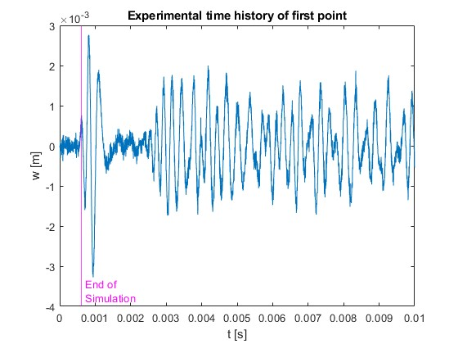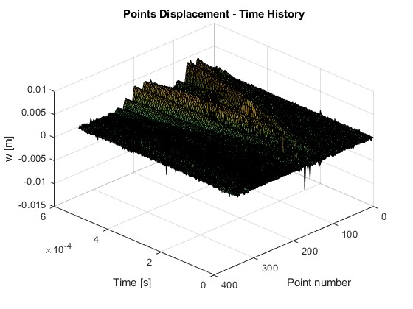

For the waterfall plot, we choose to realize the plot for 10-time instants. On the x-axis we have the beam points.

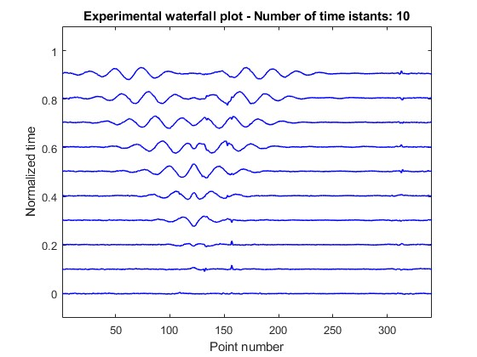

Fixing a point on the x-axis and considering a vertical line in it, we can reconstruct its time history. For a time history, taking the DFT we have a certain amplitude that depends on the point and the excitation frequency: A=A(x,Ω)

To perform the numerical simulation, we consider a *FEM model*. We consider a number of elements equal to 250 to not have too heavy computations. So, we have a number of nodes equal to 251 and a number of dof equal to 502, considering for each node translation and rotation. Being in free-free boundary conditions, all nodes are free. Based on this, we compute the mass and the stiffness matrixes and the rotational nodes where the moments are applied. Initially, we assume no damping for simplicity (and also because we find consistent results concerning the experimental ones).

To simulete the model, we consider the state space representation:

$A=\left[\begin{matrix}0 & {-M}^{-1}K \\ I & 0\end{matrix}\right]$ $B=\left[\begin{matrix}{-M}^{-1} \\ 0\end{matrix}\right]$ $z=\left[\begin{matrix}\dot{w} \\ w\end{matrix}\right]$ $\dot{z}=Az+Bf$

Then, we consider ode45 which integrates with a variable step the system of differential equations up to Ns, obtaining the velocity from it.

Thanks to it, we are now able to identify the numerical waterfall plot:

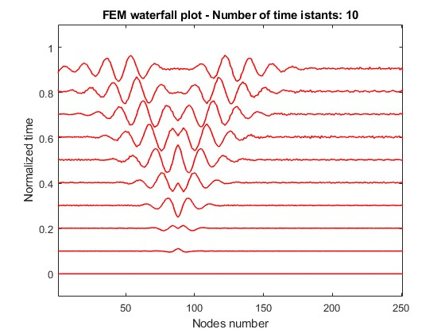

*Comparison of waterfall plots*

To compare the experimental and FEM waterfall plots, we consider normalized horizontal axis to have correspondence with respect to the positions. We can observe that for the points from 0 to 0.386m (point=126,node=92) the two plots are practically overlapped, whereas for the points from 0.418m (point=143, node=105), the FEM plot has a small delay to the experimental one. This finds correspondence in the single-point time-histories plots and also in the simulation of the dynamic plot.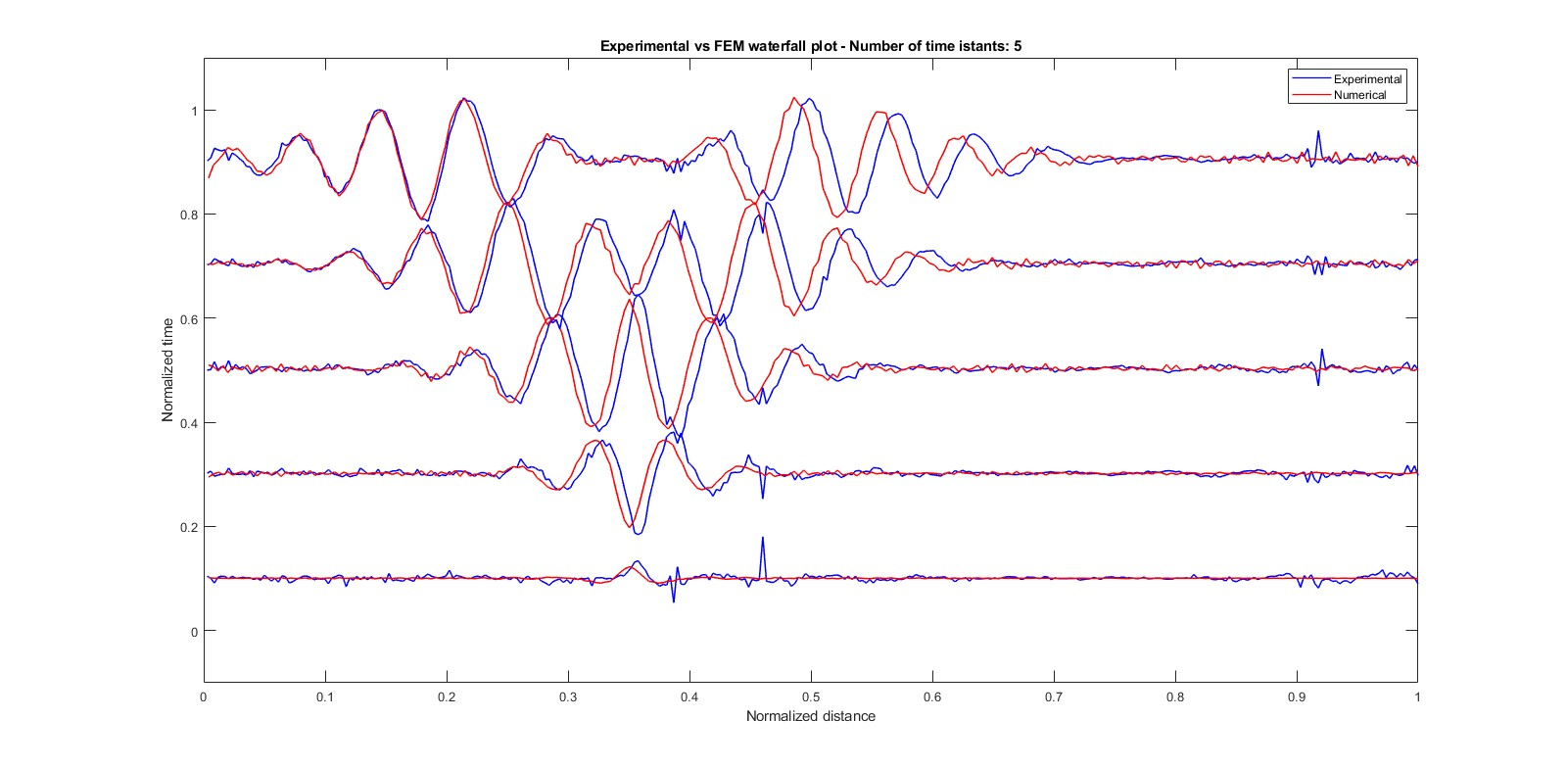

*Comparisons of the single point time-histories*

Considering the established duration of the simulation (Ns=150 which corresponds to Tend=5.96⸳10-4 s), we have correspondences among the experimental and the FEM time history in the points where the wave has already propagated (thus approximately between point 5 (=0.022m) and point 234 (=1.0296m). This statement finds correspondence concerning the waterfall plot. This is also confirmed by observing the order of magnitude of the time histories: in point 109 we have ten times the order of magnitude of point 300. Hence, outside the upper cited interval, we have noise. Through this observation, we can state that the FEM model is significant in this case only in the interval included between 5 and 234, where we do not have noise.

We can observe that the wave has traveled approximately with the same speed inside the bar: in particular, as confirmed by the comparison of waterfall plots, the FEM model has a small delay starting from 0.418m (point=143, node=105).

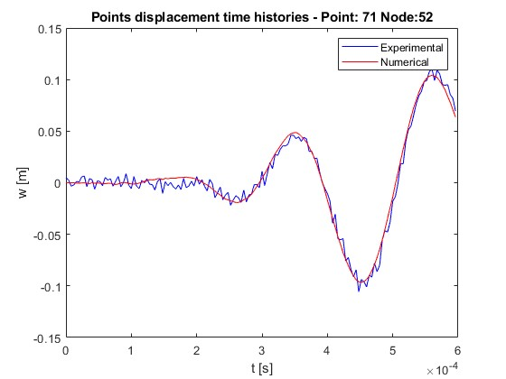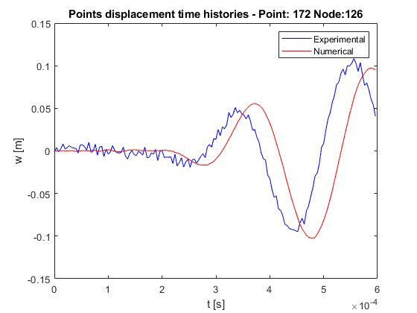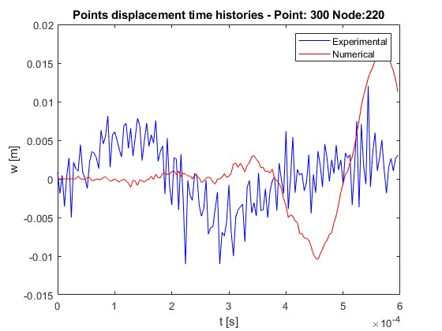

Repeating the same procedure considering this time a longer simulation time (Ns=375, which corresponds to 15⸳10-4 s) and reducing the number of FE (Nel=170) to ease the computations, we can observe that the model is still fairly accurate also after that the wave has hit the boundary:

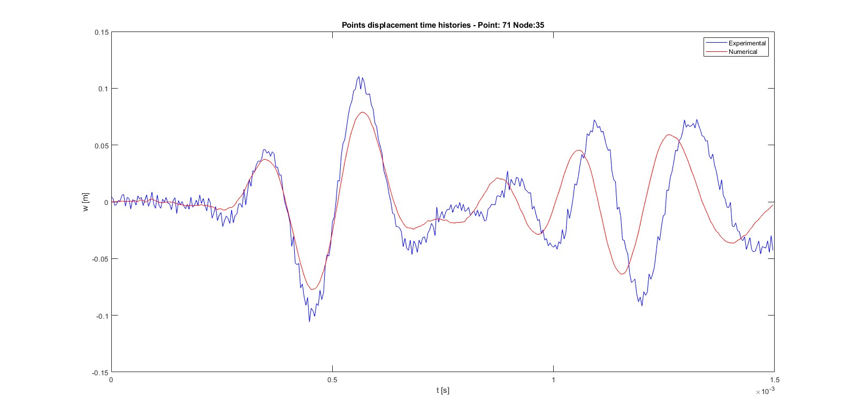

*Comparisons of dynamic plot*

Also in this case to perform the dynamic plot comparison, a normalization of the horizontal axes has been done. The resemblance has been taken at 10 different time instants in the simulation time: 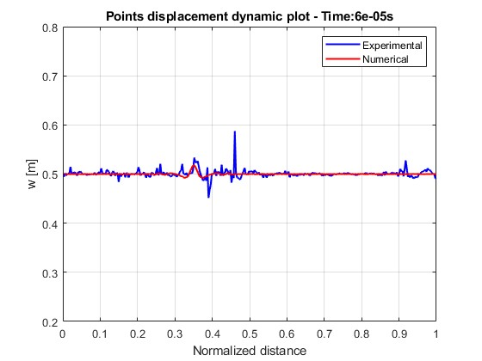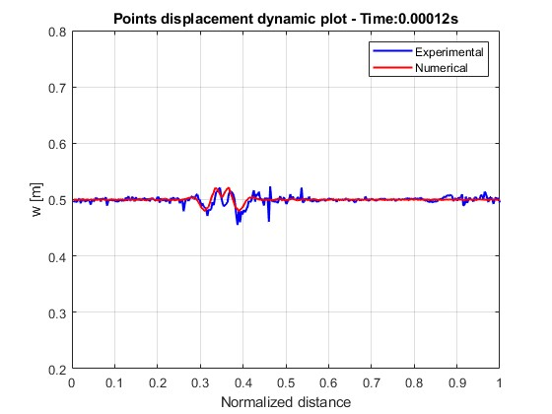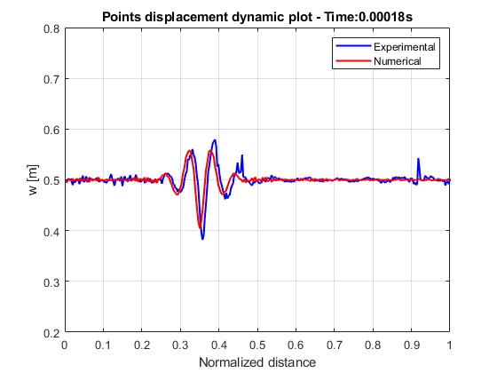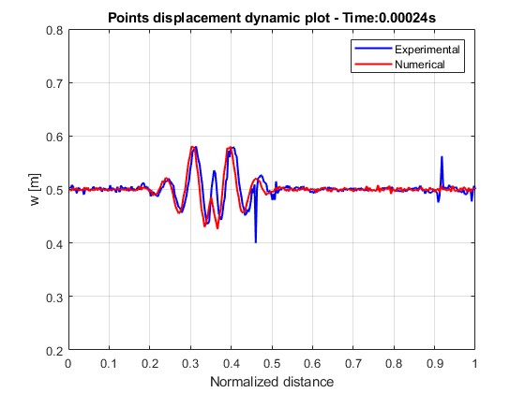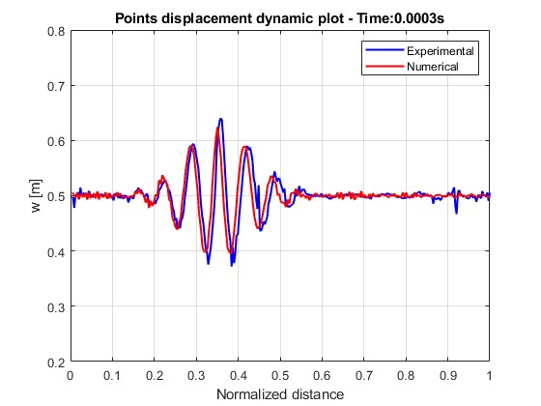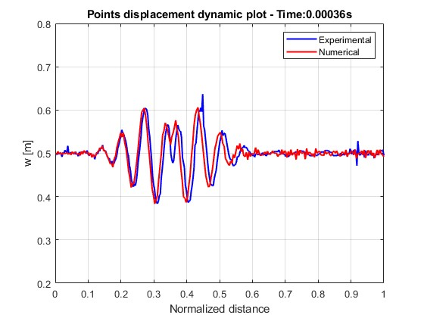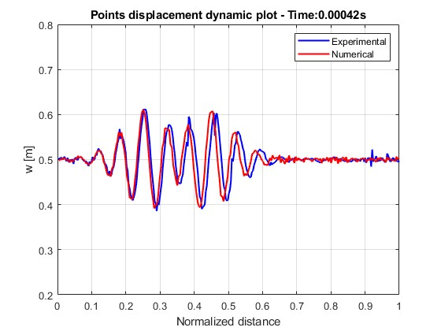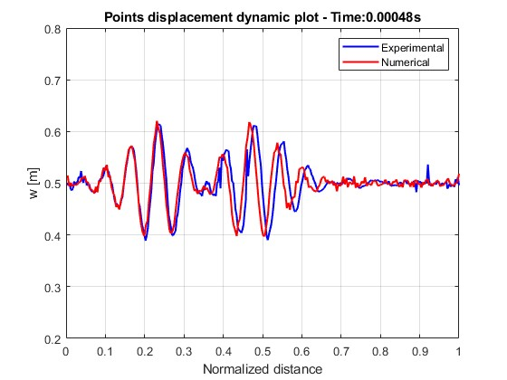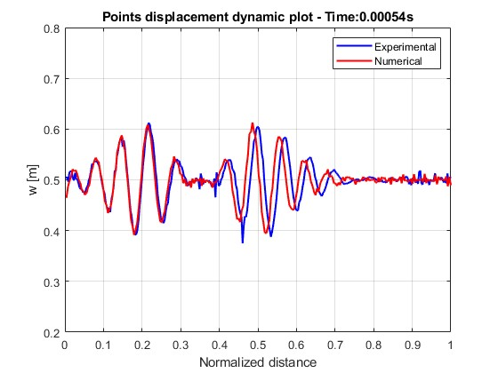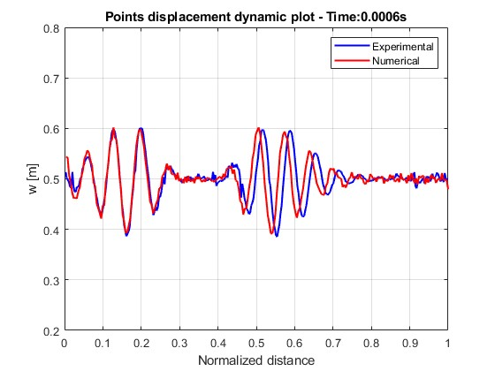

With the dynamic plot, we can identify the evolution in time of the phenomena for each analyzed point. Also from it, we can confirm that the FEM model has a small delay starting from 0.418m (point=143, node=105), as expressed by the comparison of waterfall plots.

## Dispersion relation

We identify at first the analytical dispersion relation, knowing that for a bending beam it holds: $ω= ±{\sqrt{\frac{YI}{m}}k}^{2}$

On the dispersion relation, we choose to plot the points described by the natural frequencies and the corresponding natural wavenumber, to enhance that they correctly lay on the curve. This is due to the fact that the waves can propagate only with the frequency and wavenumber described by the dispersion relation. How to find the natural frequencies will be described in the upcoming sections.

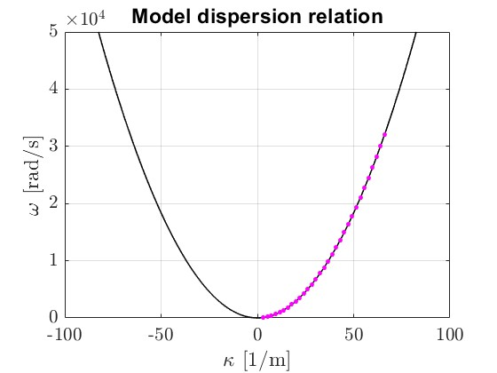

To realize the comparison between the analytical and the experimental dispersion relation, we choose to normalize the y-axis with the highest identified natural frequency discovered solving the characteristic equation. To reconstruct the experimental dispersion relation we apply first zero-padding to the experimental output datapoint. *Zero-padding* is a technique that allows improving the resolution by adding zeros: putting zeros in time, we improve frequency; putting zeros in space we improve the wavenumber. After it performing *FFT2* and *FFTshift*, we are able to identify the experimental dispersion relation described by the energy content obtained with *contourf* (A=A(k,ω)). Then, the same procedure is applied to the velocity obtained through the FEM model.

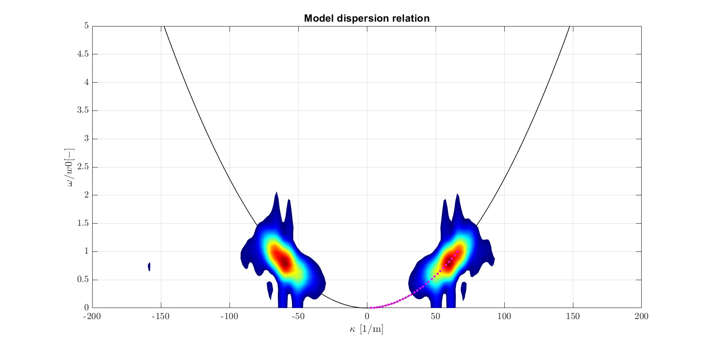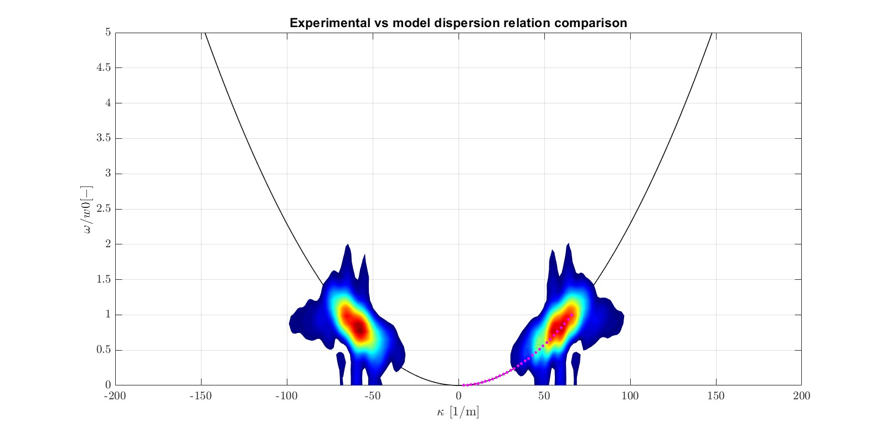

Observing the plot, we correctly find that the experimental dispersion relation, described by the energy content of the signal, coincides mainly with the numerical one.

# Steady-State Analysis

In this case, two experimental datasets are provided: the first one related to the bandwidth B1=[200-10000] Hz and the second one to the bandwidth B2=[10000-40000] Hz. Here, the experimental FRF are given with abscissa in Hz and ordinate m/s over V. In the case of the B1 dataset, the FRF are provided for 105 points along x (from -0,0111m to 1,4665m), whereas for the B2 dataset, they are provided for 209 points along x (from -0,0104m to 1,4649 m). These sampled points along the x-axis are the pick-up points.

The FRF will be expressed considering the angular frequencies.

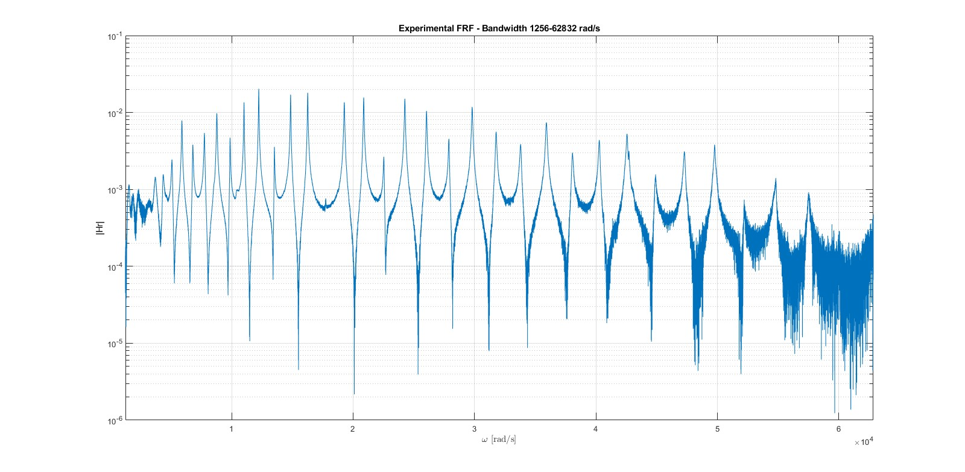 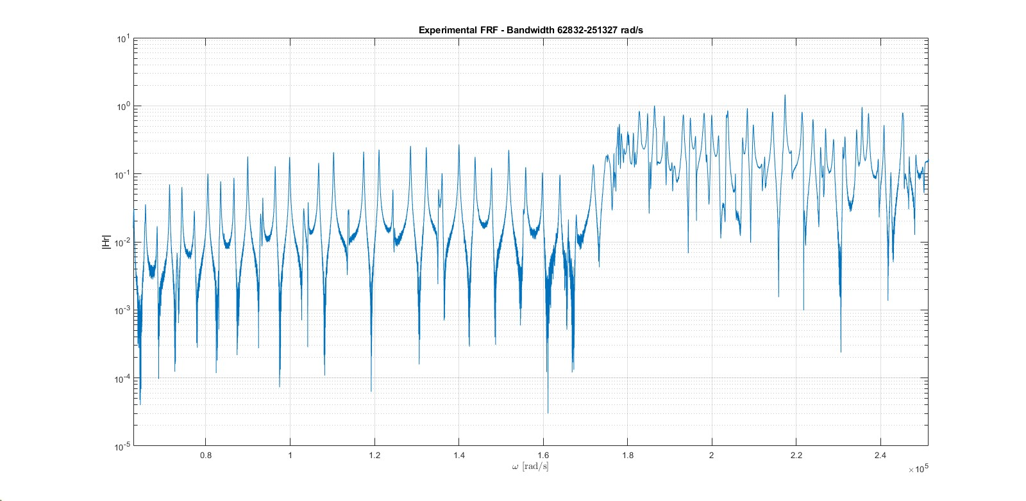

The natural frequencies and modal damping will be identified considering the techniques of experimental modal analysis.

*Identification of experimental natural frequencies*

An attempted way is the employing of the function *findpeaks*: settling proper parameters after some trials and performing post-processing considering that the natural frequencies are approximately at $-\frac{π}{2}$ or multiples (assuming low damping), we are able to estimate the experimental natural frequencies.

This technique resulted anyway not very suitable for this case, due to the noisy nature of the data, particularly also near the peaks.

We remark on the fact that the estimation of the natural frequency considering jointly the peak and the phase plot at $-\frac{π}{2}$ or multiples provides good results in the case of low-damped systems.

*Identification of modal damping*

To find the modal damping two approaches will be considered:

* Half-power points method:

From the peak information, where approximately we have the natural frequency $ω_{x}$, we can deduct the damping exploiting the fact that the peak amplitude is proportional to it. Found the peak, we identify the half-power points (points where the Fourier transform corresponds to half the power) and their corresponding frequencies.

*Half power points: $\frac{\sqrt{2}}{2}{\left|Hr\right|}_{max}$* *Damping for the x-mode*: ${ζ }_{x}≅\frac{{ω_{2}}^{2}-{ω_{1}}^{2}}{4{ω_{x}}^{2}}$

Considering the mode resonating at 38062.5 rad/s, we estimate a damping ratio equal to: $ζ$ =1.535 ⸳10-3

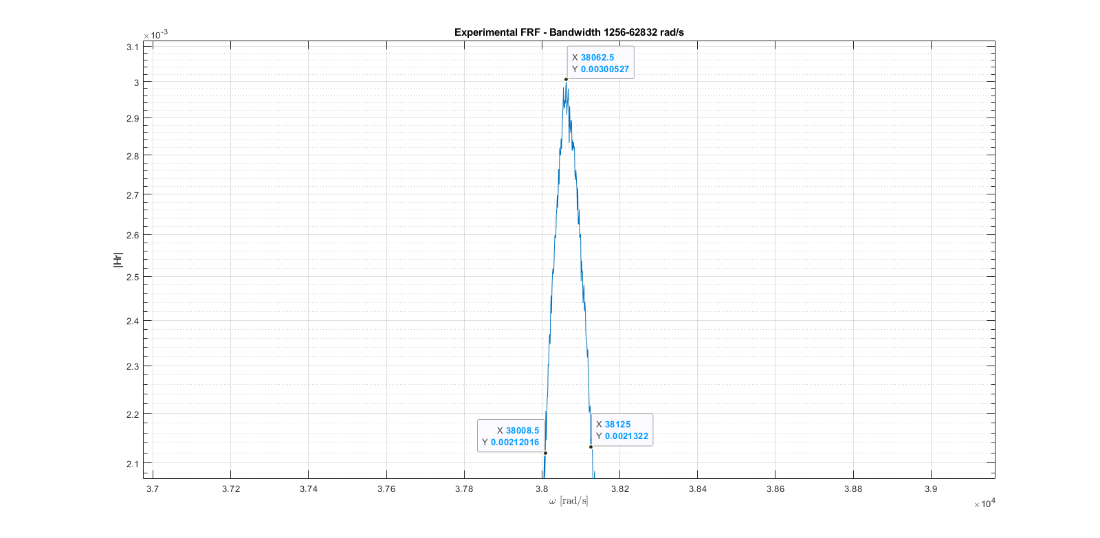

We have to remember the fact that the half-power method provides good results as far as the magnitude of the FRF is precisely identified and can be applied only when the different peaks in the FRF plot are significative distant from each other to assume the system as 1-dof. We also remark on the fact that the less the damping ratio, the more the peak is tall and narrow, and so the frequencies of the half power points get closer.

* Damping from the phase plot:

Finding the derivative in correspondance to the natural frequency, we are able to estimate the damping ratio, thanks to the following formula:

$${\left.\frac{∂φ}{∂ω}\right|}_{ω=ω_{x}}=-\frac{1}{{ζ }_{x}ω_{x}}$$

From this formula, we deduct that the less is the damping ratio, the more the derivative of the phase tends to infinite, and so to be vertical (and so the phase to be discontinued in the resonance frequency and the peak going to infinite); The more is the damping, the less is the phase slope.

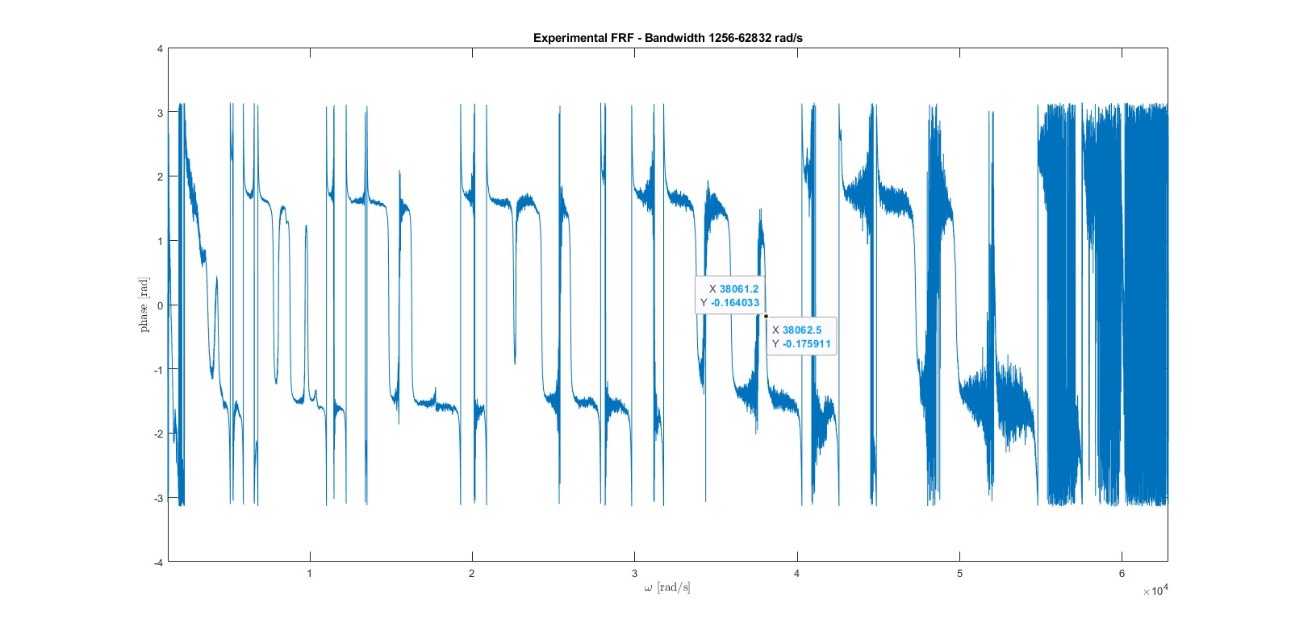

Considering the previous mode resonating at 38062.5 rad/s, we estimate a damping ratio equal to: $ζ$ =2.875 ⸳10-3

## Frequency Response Functions

The FRF will be identified between the applied force and the first pick-up point, the one on the boundary at the beginning of the beam.

*Analytical method*

To find the FRF between the applied force and a pick-up point, we consider the displacement described as $w\left(x,t\right)=ϕ\left(x\right)η\left(t\right)$. Substituting it in the equation of motion $YI\frac{∂^{4}w}{∂x^{4}}+m\frac{∂^{2}w}{∂t^{2}}=0$ and taking some computations, we find the expression associated to the space solution: $ϕ(x)=Acos(\frac{\sqrt{ω}}{C}x)+Bsin(\frac{\sqrt{ω}}{C}x)+Ccosh(\frac{\sqrt{ω}}{C}x)+Dsinh(\frac{\sqrt{ω}}{C}x)$

To it, we apply the free-free boundary conditions:

$$@x=0:\left\{\begin{aligned}{\left.\frac{∂^{2}w}{∂x^{2}}\right|}_{x=0}=0 ⇔ -A+C=0 \\ {\left.\frac{∂^{3}w}{∂x^{3}}\right|}_{x=0}=0 ⇔-B+D=0\end{aligned}\right.$$

$$@x=L:\left\{\begin{aligned}{\left.\frac{∂^{2}w}{∂x^{2}}\right|}_{x=L}=0 ⇔-Acos(l_{r})-Bsin(l_{r})+Ccosh(l_{r})+Dsinh(l_{r})=0 \\ {\left.\frac{∂^{3}w}{∂x^{3}}\right|}_{x=L}=0 ⇔Asin(l_{r})-Bcos(l_{r})+Csinh(l_{r})+Dcosh(l_{r})=0\end{aligned}\right.$$

Where, we have considered: $\frac{\sqrt{ω}}{C}=\frac{l_{r}}{L}$ From this system, we can identify the characteristic equation for a free-free beam: $cos(l_{r})cosh(l_{r})-1=0$ Employing the function *fzero* and taking a sweep with respect to the initial condition, we can find its solution and so also the natural frequencies and natural wavenumbers. Here below is reported the plot associated with the characteristic equation.

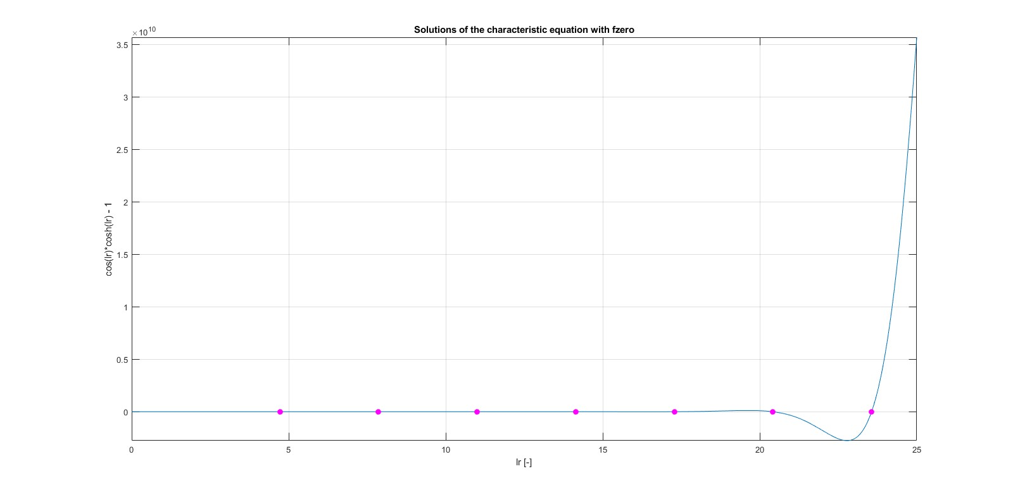

Considering again the system, we can find the coefficient: $D_{r}=\frac{cos(l_{r})-cosh(l_{r})}{sinh(l_{r})-sin(l_{r})}A_{r}$

We have now the expression associated to the r-modal shape, related to the r-solution of the characteristic equation: $ϕ_{r}(x)=A_{r}(cos(\frac{l_{r}}{L}x)+cosh(\frac{l_{r}}{L}x)+\frac{cos(l_{r})-cosh(l_{r})}{sinh(l_{r})-sin(l_{r})}(sin(\frac{l_{r}}{L}x)+sinh(\frac{l_{r}}{L}x)))$

Where, for the arbitrary constant, we consider the mass normalization to have the property of orthogonality conditions: $A_{r}=\sqrt{\frac{1}{mL}}$

Employing it, we are now able after some computations to identify the modal amplitude: $H_{r}=\frac{F_{r}}{{ω_{r}}^{2}+ j2{ζ }_{r}{ω_{r}ω - ω}^{2}}$

Based on it, we have in the end the displacement expression, given from the contributions of the R-modes considered: $w(x,t)=\sum_{r=1}^{R}{ϕ_{r}(x)H_{r}e^{jωt}}$

In the analytical FRF are considered a number of modes equal to R=34. We remember that the more the frequency to analyze, the more R has to be large.

We are now able to obtain the analytical FRF:

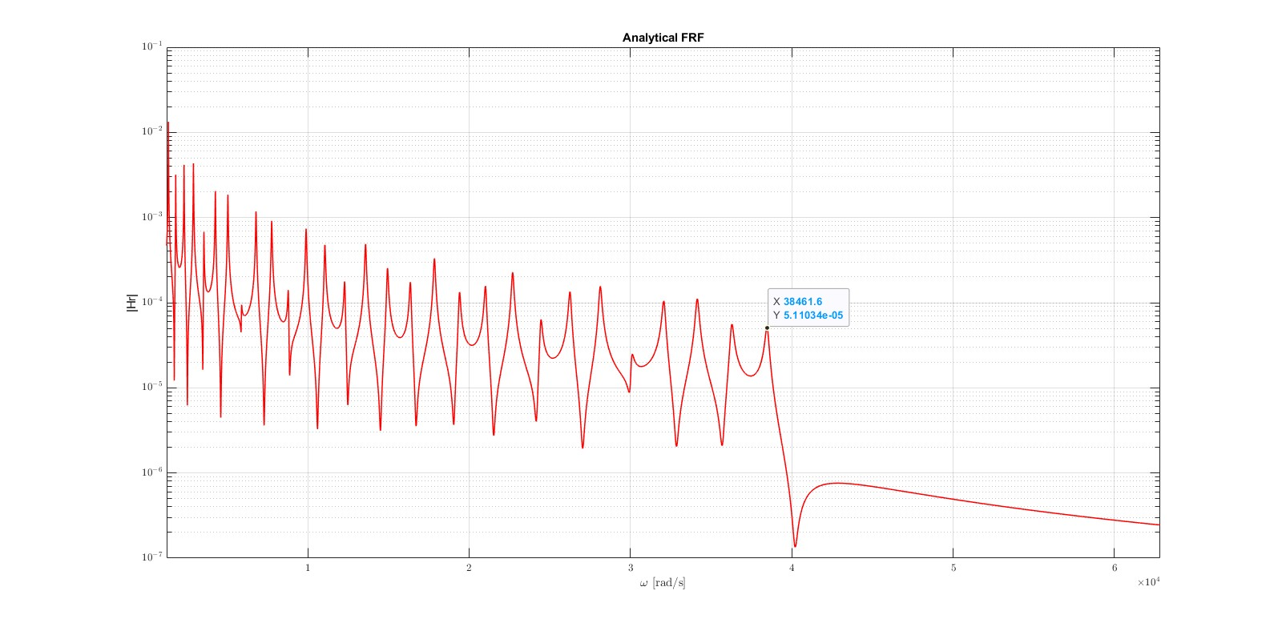

We observe that even if we want to consider additional resonance frequencies, and so we impose the corresponding number to find their solutions in the characteristic equations, we are able to represent modes up to the 34th solution found in solving it. For this reason, the comparison with respect to the experimental results will be carried out with the FEM. We can also observe that the resonance frequencies of the analytical model (e.g. 38461.6 rad/s) are slightly different compared to the one discovered solving the characteristic equation (e.g. 38473.42 rad/s): this is due to damping. We can verify that the natural frequencies, apart from damping, correspond to the ones identified in the dispersion relation.

*FEM method*

Also in this situation, for each node as dof we consider the translation and the rotation. After properly constructing the mass and stiffness matrixes, we identify the nodes where the applied moments are acting. We choose to move to modal space to consider properly the estimeted dimensionless damping. We compute the eigenvalues and eigenvectors associated with the eigenvalue-eiegenvector problem: $(-ω^{2}+{M_{ff}}^{-1}K_{ff})=0$

We can now build the mass and stiffness modal matrixes, considering the matrix $ϕ$ composed by the identified eigenvectors: $M_{mod}= {ϕ^{'}M}_{ff}ϕ$ $K_{mod}= {ϕ^{'}K}_{ff}ϕ$

And moving the force to the modal space: $Q_{mod}= ϕ^{'}F$

For the modal damping $C_{mod}$, for simplicity we consider an identity matrix multiplied by the estimated value from the phase plot (2.875⸳10-3). We remember that in this way through modal coordinates we will get a system of decoupled equations, where every one of them represents a 1-dof system.

Identified with a proper expression the modal coordinates q, we move back to the physical space ($u(x,t)= ϕq$) and so able to identify the FRF. Here below, is reported the FRF identified considering 75 elements (so 76 nodes and 152 dof):

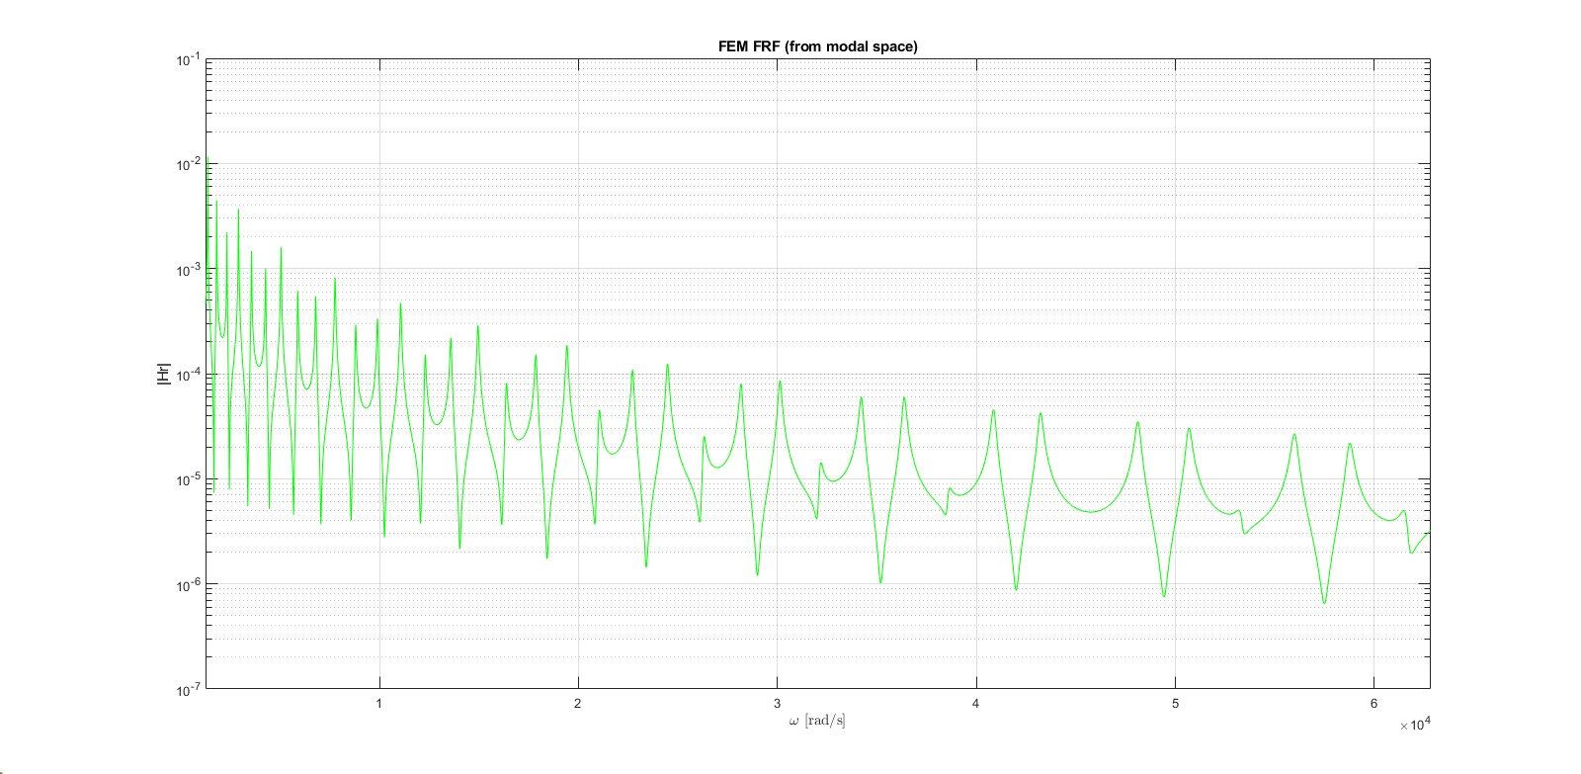

*FRF comparisons*

Due to the numerical issues associeted to the analytical model for high frequencies, the comparisons will be proposed confonting the experimental and FEM results.

* Bandwidth B1=[200-10000] Hz:

For this bandwidth, the comparisons will be presented both considering the FEM developed considering the estimation of the damping from the half-power points method and the phase plot:

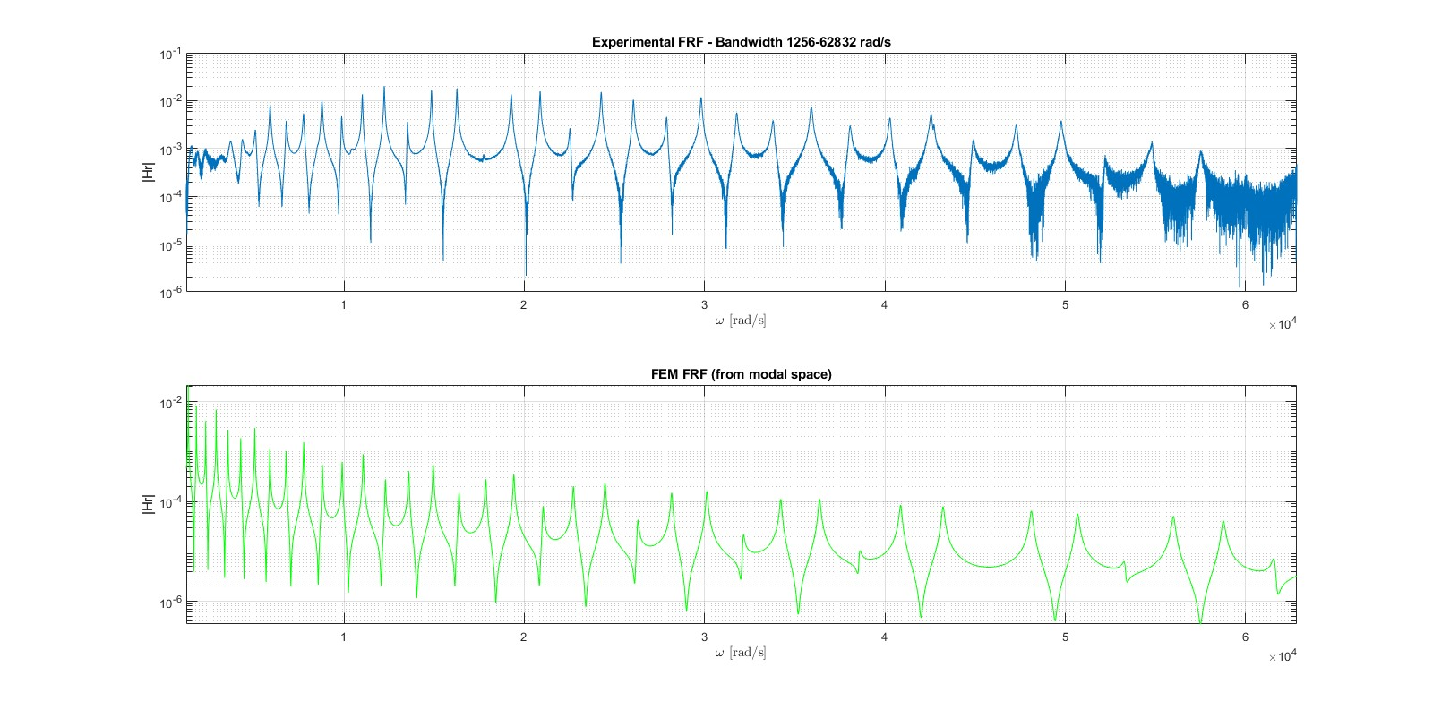

FEM FRF obtained considering: 75 elements, modal damping 1.535 ⸳10-3 (estimated from half-power points method)



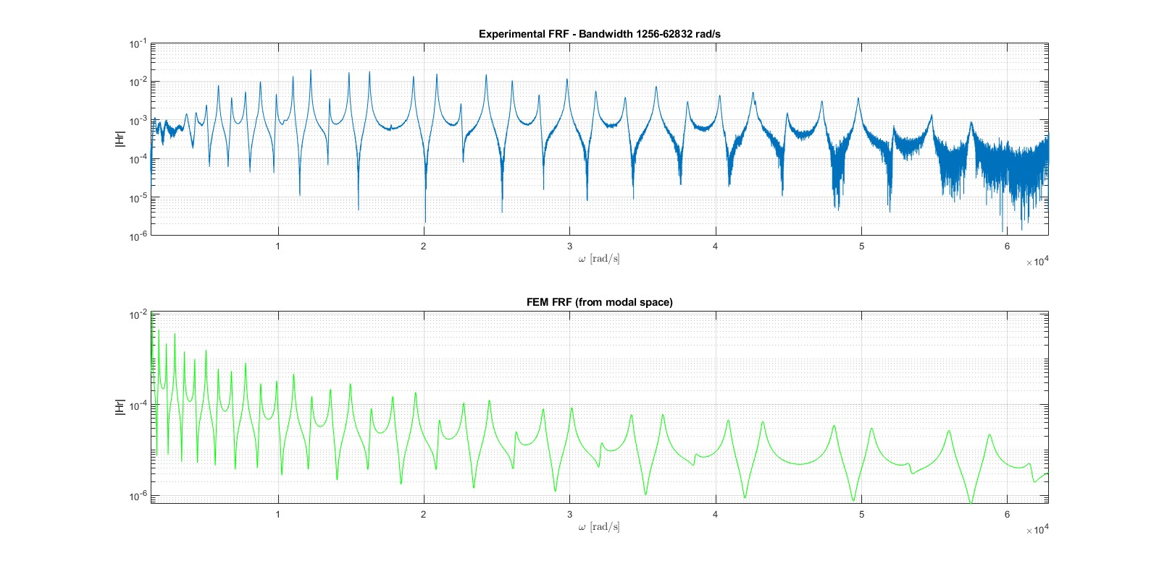

FEM FRF obtained considering: 75 elements, modal damping 2.875⸳10-3 (estimated from the phase plot)



Since at high frequencies the FEM model with damping estimated from the phase has better results, this technique will be considered to estimate the damping for the FEM model for the bandwidth B2.

* Bandwidth B2=[10000-40000] Hz:

For what concerns the FEM related to the second bandwidth B2 (10000-40000 Hz), it has been taken a first attempt considering the settings of the first bandwidth B1 (200-10000 Hz), thus 75 elements and damping obtained from the phase plot 2.875⸳10-3. This configuration leads to poor results, therefore, since the significantly increasing frequencies and a different slope of the peaks, the number of FE has been augmented up to 150 and a new estimation of the damping ratio equal to 6.976⸳10-4 has been performed.

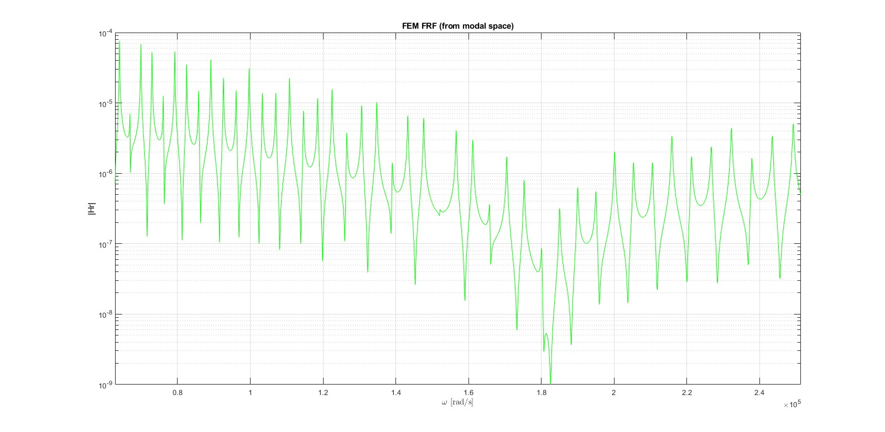

With these settings, significative improved result are achieved:

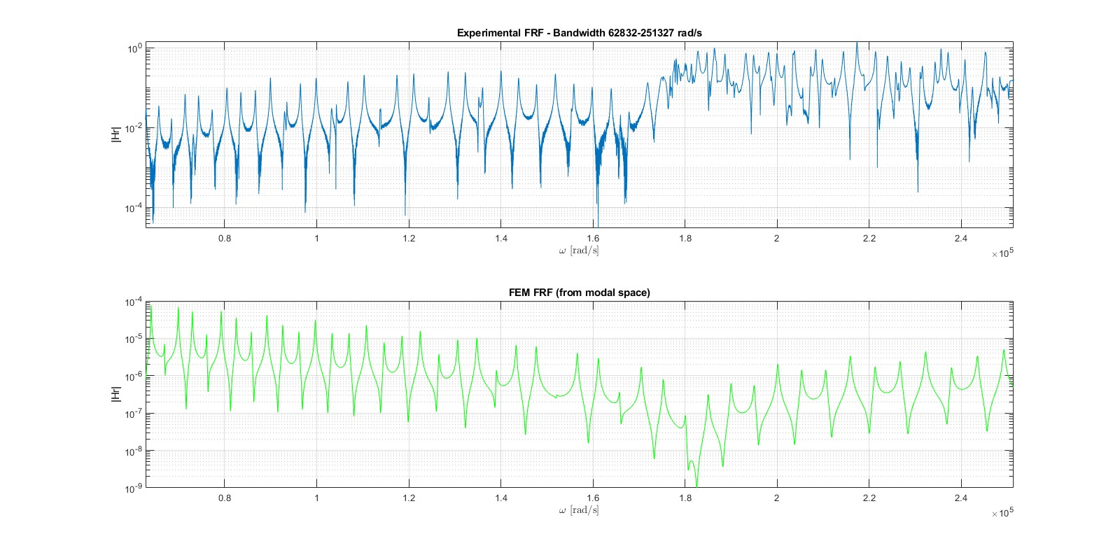

FEM FRF obtained considering: 150 elements, modal damping 6.976⸳10-4 (estimated from the phase plot)

For what concerns the frequencies next to about 1,885⸳105 rad/s (30 kHz), it can be observed that the model is not very representative of the experimental situation: this is due to the formation of additional modes resulting from the 3D dimensions of the specimen not accounted for in the 1D Euler-Bernoulli model.

To be remember the fact that the length of the single element has to be chosen according to:

$Ω_{max}=c(2πf_{max}) where 1.5≤c≤3$ $L_{el}≤L_{max}= \sqrt{\frac{π^{2}}{Ω_{max}}\sqrt{\frac{YI}{m}}}$

Verifying this condition, we guarantee that the single element remains in the quasi-static region that good results are provided by the FEM. Considering in this case c=2.25, we get:

${\left.Ω_{max}\right|}_{B_{1}}=141371.67 rad/s ⇒ {\left.L_{max}\right|}_{B_{1}}=0.0227 m$ with $N_{el}=75 ⇒ L_{el}=0.02 m$

${\left.Ω_{max}\right|}_{B_{2}}=565486.68 rad/s ⇒ {\left.L_{max}\right|}_{B_{2}}=0.0113 m$ with $N_{el}=150 ⇒ L_{el}=0.01 m$

It is clear that observing the experimental FRF, to obtain optimal results, the number of elements of the FE should be kept as high as the calculator allow and the estimation of the modal damping should be done for every resonance peak. To be mentioned also the fact that eventual changes in the cross-section area and area moment of inertia have not been taken into account in the models. A remark should be done on the choice of the pick-up point. The first point available of the dataset, hence on the free bound could be a peculiar situation; It can be that taking the same analysis on points more inside the boundaries, could have brought results more similar to the experimental one.

## Modal Shapes

First will be presented the modal shapes came from the analytical and the FEM models, then comparisons of the derived experimental modal shapes in the two studied bandwidths will be proposed.

*Analytical modal shapes*

They will be shown the first five modes of vibration and then the first three modes included in the bandwidth B1:

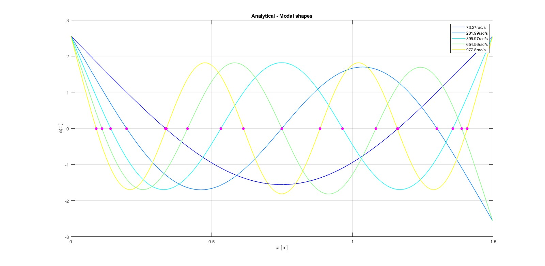

Modes are included in the bandwidth B1 starting from the sixth 1365.68 rad/s (that corresponds to 217.35 Hz):

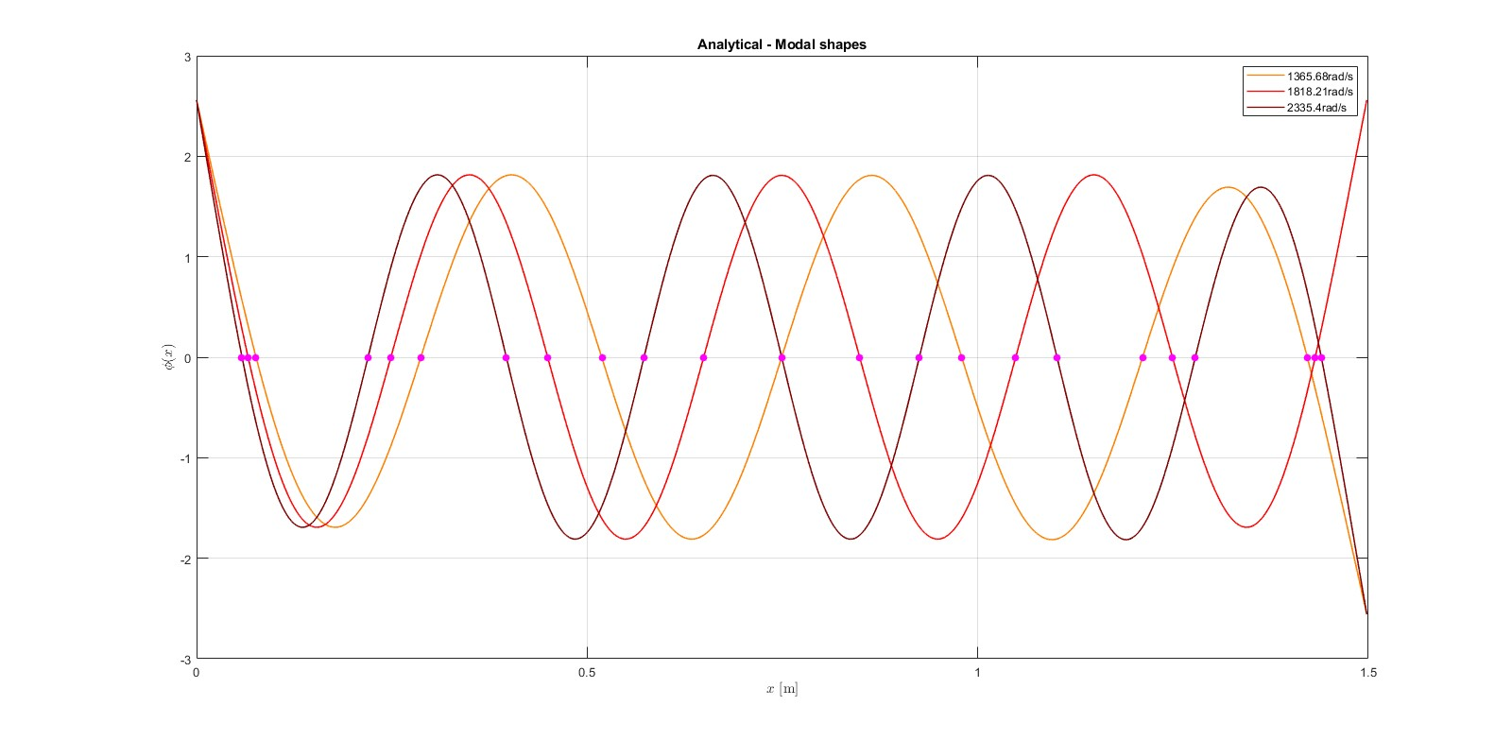

We choose to emphasize the nodal points since they are relevant to the design of control techniques and also for placing sensors and actuating forces. From these plots, we can observe correctly that at the boundaries we have that the displacement and its first derivative are not null, being in the free-free case; In addition, it can be noticed that the modal shapes are either symmetric or antisymmetric to the beam middle point: this is due to the symmetric boundary conditions. We remember that the modal shapes are defined apart from a scaling coefficient, therefore apart from the amplitude.

*FEM modal shapes*

The analysis is taken considering 75 elements. It is clear that, as said for the FRF, increasing the number of elements we obtain better results, thanks to the additional nodes.

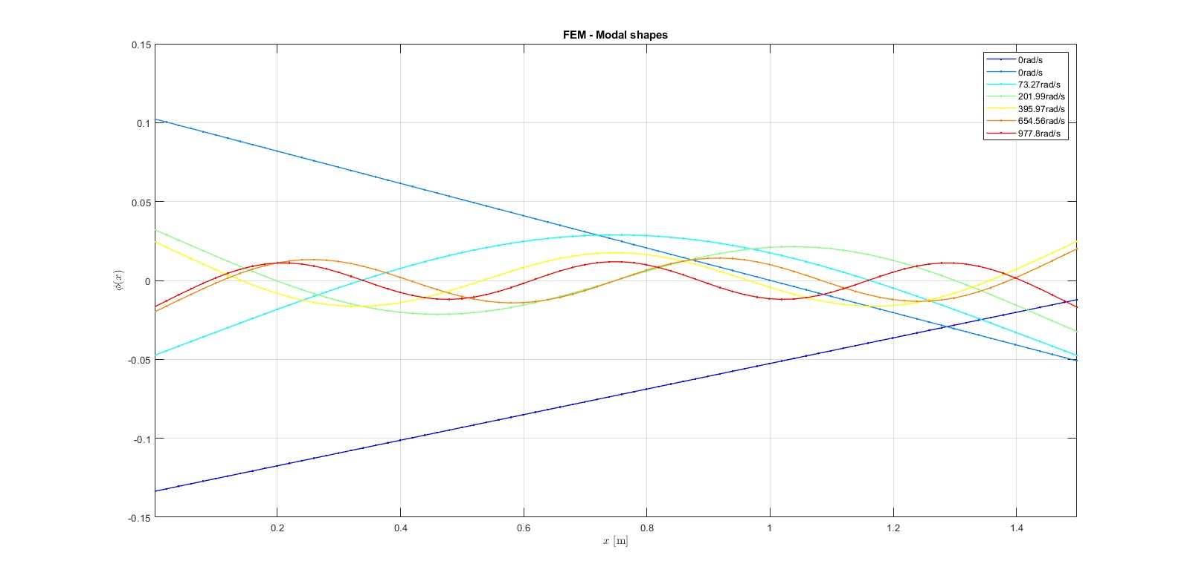

The first two modes which have zero natural frequency, represents that the structure can have rigid movement without excitations: this is due to the free-free boundary conditions.

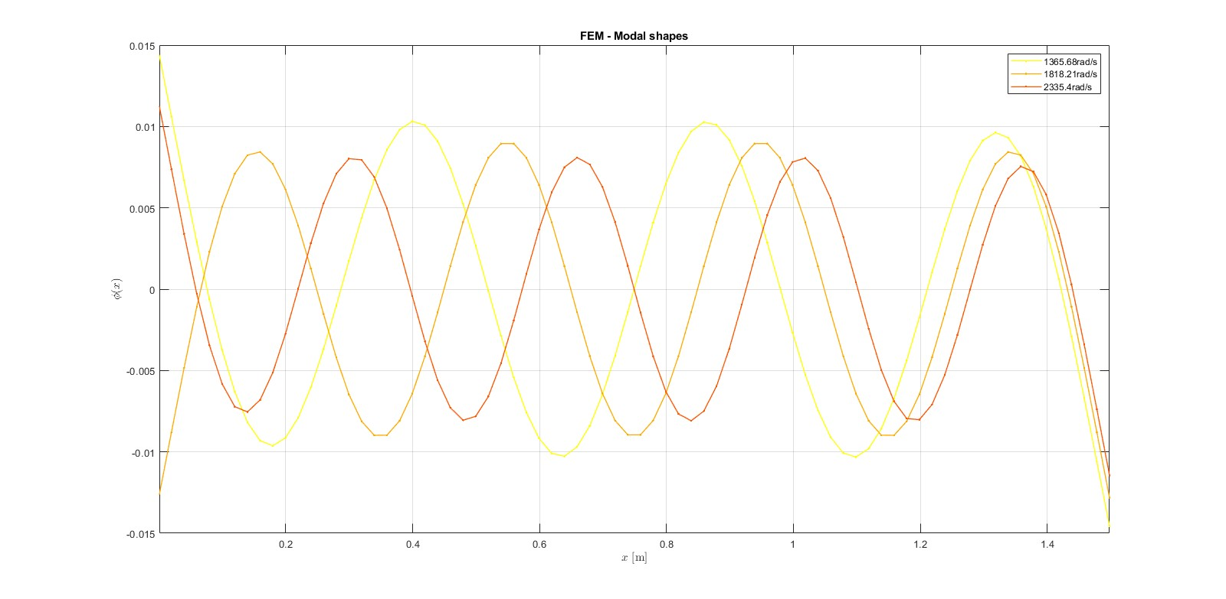

It can be noticed that the obtained modal shapes have the same shape as the analytical ones but are reported differently: this is due to the definition of modal shapes, which are defined apart from a constant, and the eigenvectors normalization done by the software. From here, it can also be observed that the natural frequencies obtained from the analytical model and the FEM are practically equal.

*Experimental modal shapes and comparisons*

To identify the experimental modal shapes, we employ experimental modal analysis. Considering the FRF between the drive point xk and the pick-up point xj around the peak of resonance of the ith-mode, we can consider the approximation: $H_{jk}≅ \frac{{ϕ_{j}}^{(i)}{ϕ_{k}}^{(i)}}{-Ω^{2}m_{i}+jΩc_{i}+k_{i}}$

So, when we have: $Ω=ω_{i} ⇒ H_{jk}= (-j\frac{{ϕ_{k}}^{(i)}}{ω_{i}c_{i}}){ϕ_{j}}^{(i)}$ (due to the cancellation of mi and ki) We can observe that the first factor does not depend on the pick-up point xj Hence, assuming low damping and modes distant from each other, we can deduct the ith modal shape considering only the imaginary part of the FRF at its frequency ωi for the provided pick-up points.

Now the modal shapes will be compared in the two bandwidths:

* Bandwidth B1=[200-10000] Hz:

In this case, we have 105 pick-up points.

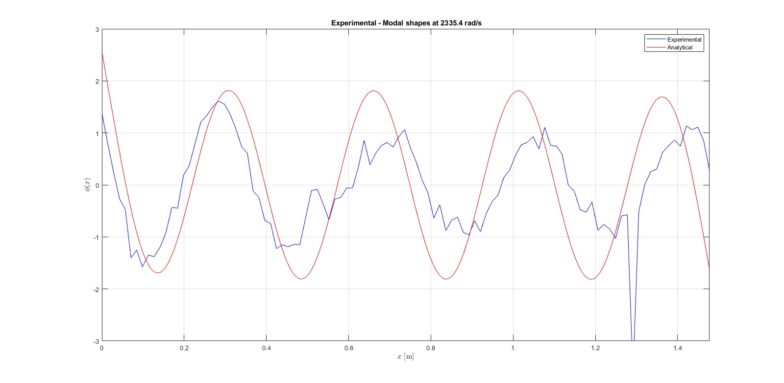

We can observe that the shape of the 8th experimental mode (2335.4 rad/s, 371.69 Hz) does not coincide a lot with the analytical one: this is because the other resonance peaks around the eighth resonance frequency are not so distant. This can be observed from the experimental FRF.

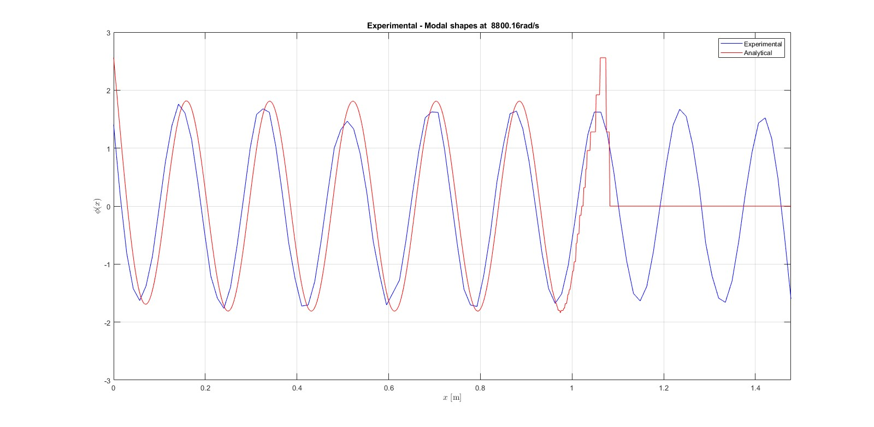

For the 16th experimental mode (8800.16rad/s, 1400.59Hz), we have better results, especially for what concern the shape. It can be observed a little shift along the x-axis: this is due to the fact that the experimental natural frequency and the corresponding one identified in solving numerically the characteristic equation are near but not coincident.

The numerical issues of the analytical model can be observed also from the modal shapes plots. We remember that this model has the advantage to have an explicit solution but has problems at high frequencies.

* Bandwidth B2=[10000-40000] Hz:

In this case, we have 209 pick-up points. To avoid numerical issues, we consider the FEM model.

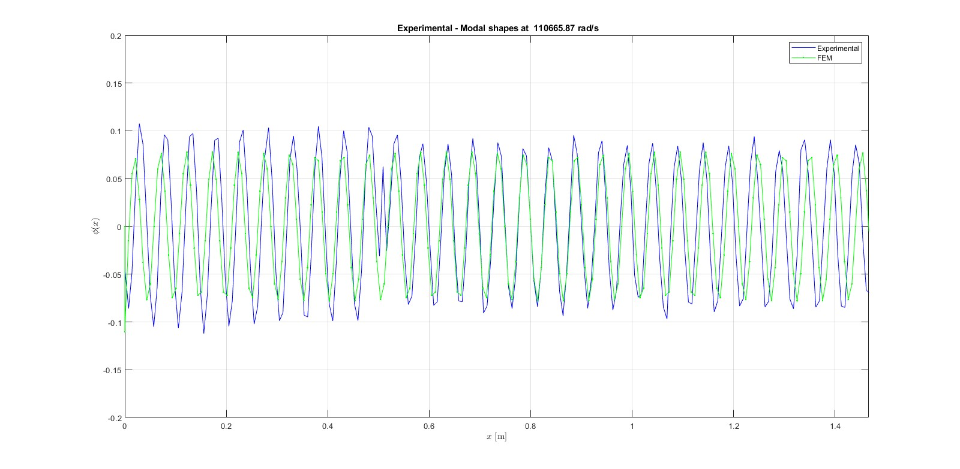

Also considering a natural frequency in the bandwidth B2 (58th mode: 110665.87 rad/s, 17613.02Hz), the experimental mode practically corresponds with the FEM one. In this case, the FEM has been developed with 209 nodes (and so 208 elements) to have correspondence with the pick-up points from the point of view of x-axis discretization.

*Modal Assurance Criterion (MAC)*

Due to numerical issues associated with the analytical approach, the MAC will be identified between the experimental modes and the FEM ones. To perform this comparison, we consider 105 nodes in the FEM model (thus 104 elements) to have the same pick-up points on the x-axis.

The MAC allows comparing the modal shapes derived from two different methods (in this case, experimental and FEM): ${MAC}_{ij}=\frac{{{|ϕ_{i}}^{t}ϕ_{j}|}^{2}}{{ϕ_{i}}^{t}ϕ_{i}{ϕ_{j}}^{t}ϕ_{j}}$

The more the MAC, the better the correspondence (the MAC is bounded between zero and one). In the MAC we expect that, if the natural frequencies derived from the two methods correspond, the highest value are on the diagonal. If we do not have this situation, we have anomalies.

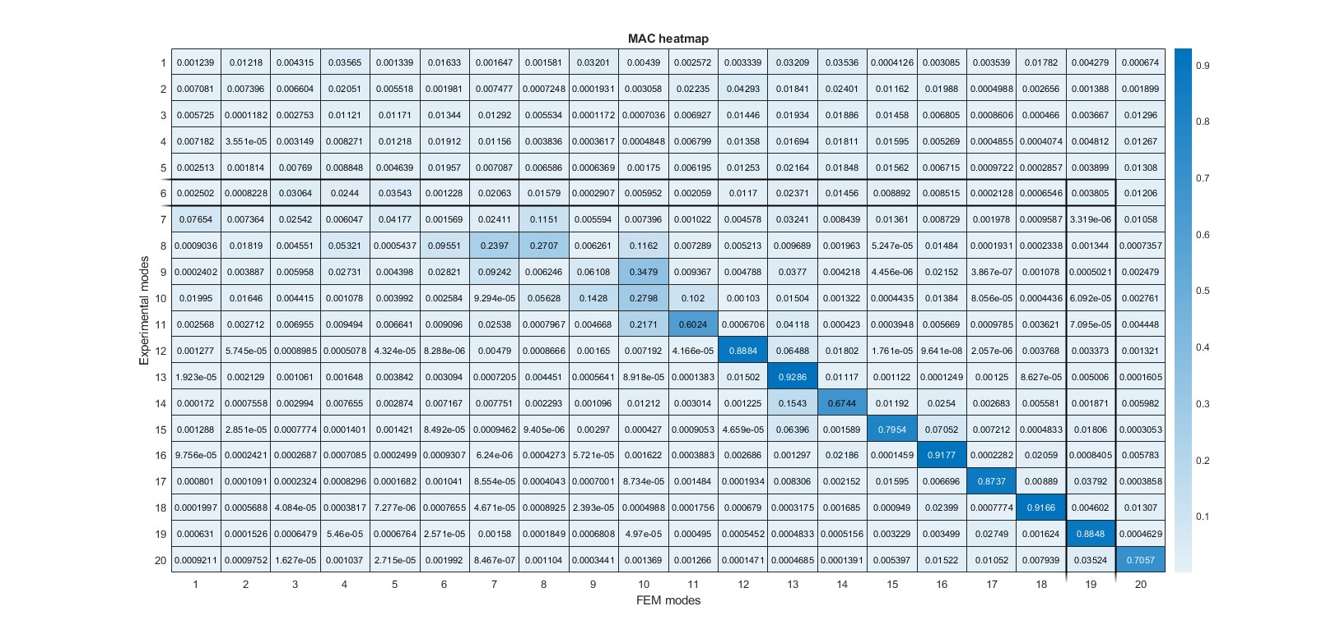

MAC has been found considering the first 20 modes (of course excluding the two associated with the rigid motions in the FEM). Observing the resultant heatmap, we can conclude that the experimental modal shapes particularly correspond to the FEM ones starting from the 12th, whereas at low frequencies the matching grade is far below. This is due to an overlapping region related to the first modes. The best experimental one with respect to the FEM is the 16th.

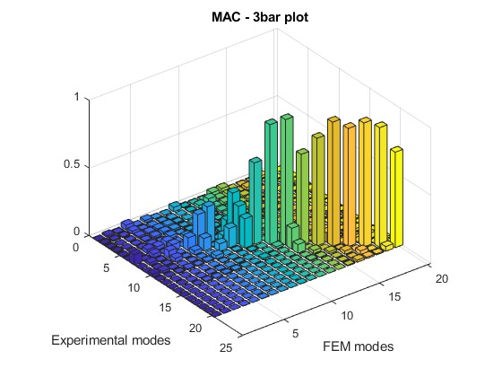

A remark should be done on the fact that the positions along the bar of the drive points do not exactly correspond with the ones of the nodes of the FEM: realizing a situation where the positions coincide, the MAC results would be improved from a numerical point of view.

# Control Strategies

In this section will be discussed the implementation of a passive control strategy with tune-mass dampers and an active one with piezo patches to suppress vibrations in the studied bandwidths.

## Passive control strategy – Tune-mass dampers

The identification of the number of resonators and their positions will be addressed by the analytical model. In this way, we have a precise position of the peaks of the mode avoiding facing too large computations of FEM (with FEM, the x-axis is discretized based on the number of nodes so to have the precise positions a high number of nodes is required).

To not influence the adjacent modes with this control strategy and to satisfy the hypothesis of 1-dof system, we chose to address with the tune-mass damper a mode with a significative distance from them: this information can be deducted from the experimental FRF.

We aim to suppress the vibrations of the 10th mode (3563.70 rad/s, 567.18 Hz), included in the bandwidth B1 (The choice of this mode has been done also keeping into account the numerical issues associated with the analytical model). For completeness, also the effect on the adjacent modes will be reported.

Firstly, to have the maximum energy dissipation, we identify the positions of the peaks of the addressed mode, as reported in the figure. Here we will set the tune-mass dampers.

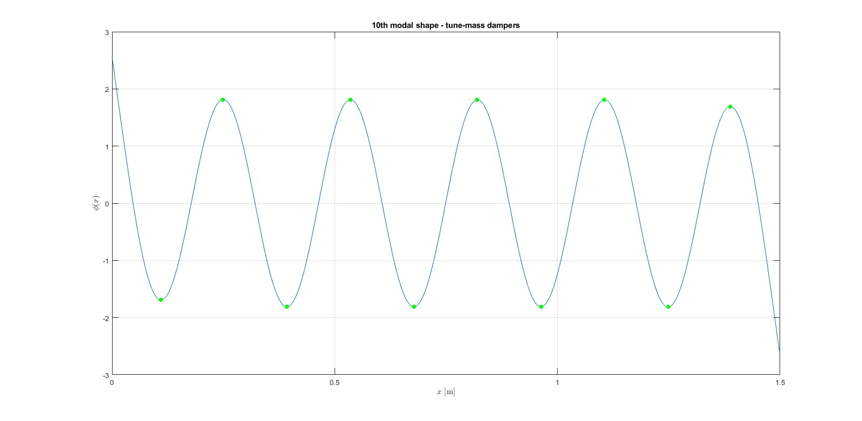

We remember that if we place the tune-mass dampers in nodal point positions, they will not affect the system. The higher the mode amplitude. the more is the tune-mass damper effect. In addition in the positioning of the tune-mass damper, we need to consider the introduced static deflection and the resistance of the structure.

We will implement a number of tune mass damper equal to 10. As loss factor for the beam, we consider its identification considering: $η_{beam}=2ζ_{beam}\sqrt{1-{ζ_{beam}}^{2}}$

So, considering the previous estimation: $ζ_{beam}=2.875⸳{10}^{-3}⇒$ $η_{beam}=0.0057$

Now, to select the proper value for the loss factor and added mass ratio of the resonators, it will be performed an analysis considering a fixed value of the added mass ratio and varying the loss factor and vice versa. The shown FRF will be the one of the first pick-up point.

*Fixed added mass ratio, variation of the loss factor*

The analysis has been carried out considering a constant value for the added mass ratio equal to $μ=5⸳{10}^{-5}$. We chose this value to better enhance the dependence with respect to the loss factor. We expect that the more the loss factor of the resonator tends to zero, the more the attenuation region is narrowed and deeper and the more the two generated peaks are high.

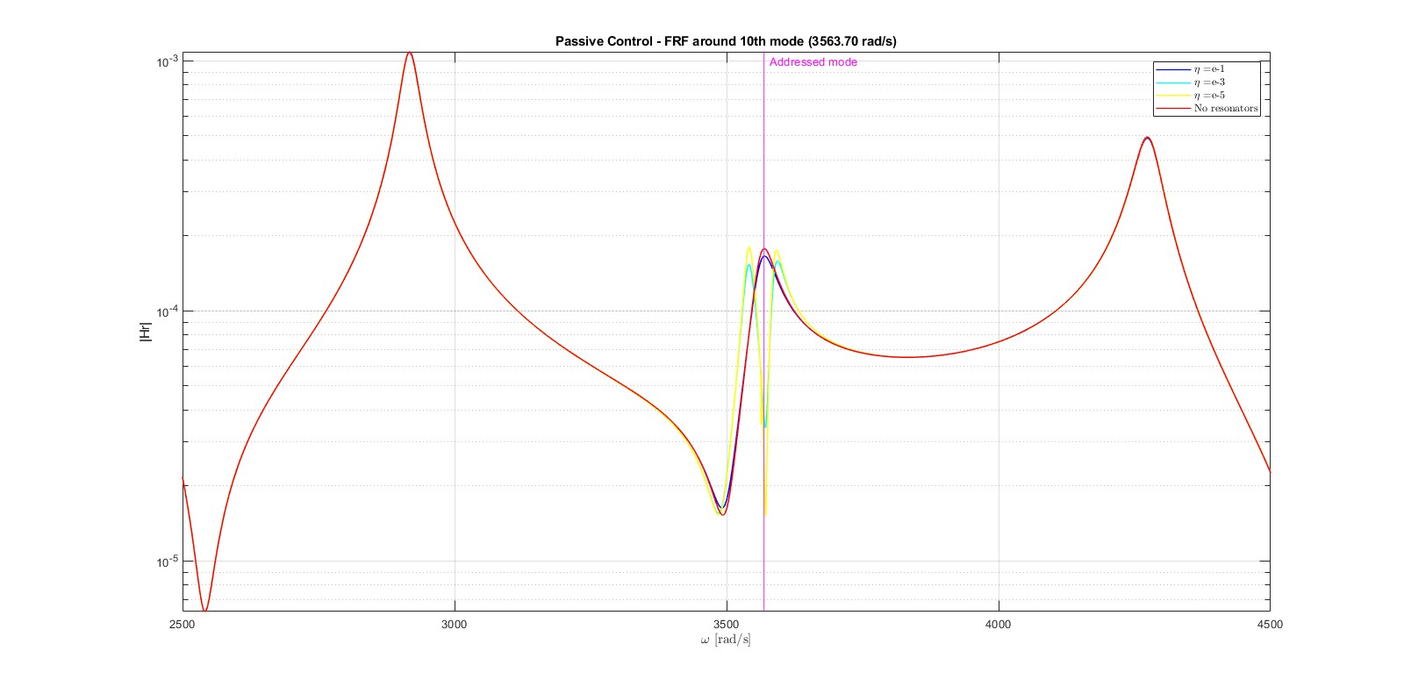

We can observe that with $η=0.1$ the initial situation is a little improved without the introduction of the new two peaks. The higher the loss factor, the more the tune-mass damper FRF and the original one are overlapped, because it is like have a rigid connection. The situation of the adjacent resonance peaks is practically the same, regardless of the loss factor value. Depending on the variability of the excitation frequency that we want to counteract, we select a proper value for the loss factor: if the excitation frequency tends to be always the same, we will select resonators with small loss factor; if it tends to vary, we will select them with a higher loss factor value.

*Fixed loss factor, variation of the added mass ratio*

The analysis has been carried out considering a constant value for the loss factor equal to $η=0.001$. We chose this value to better enhance the dependence with respect to the added mass ratio. We expect that the more the mass ratio tends to zero, the more the resonator frequency is similar to the one of the addressed mode; the more the added mass ratio is large, the more the attenuation and the attenuation region.

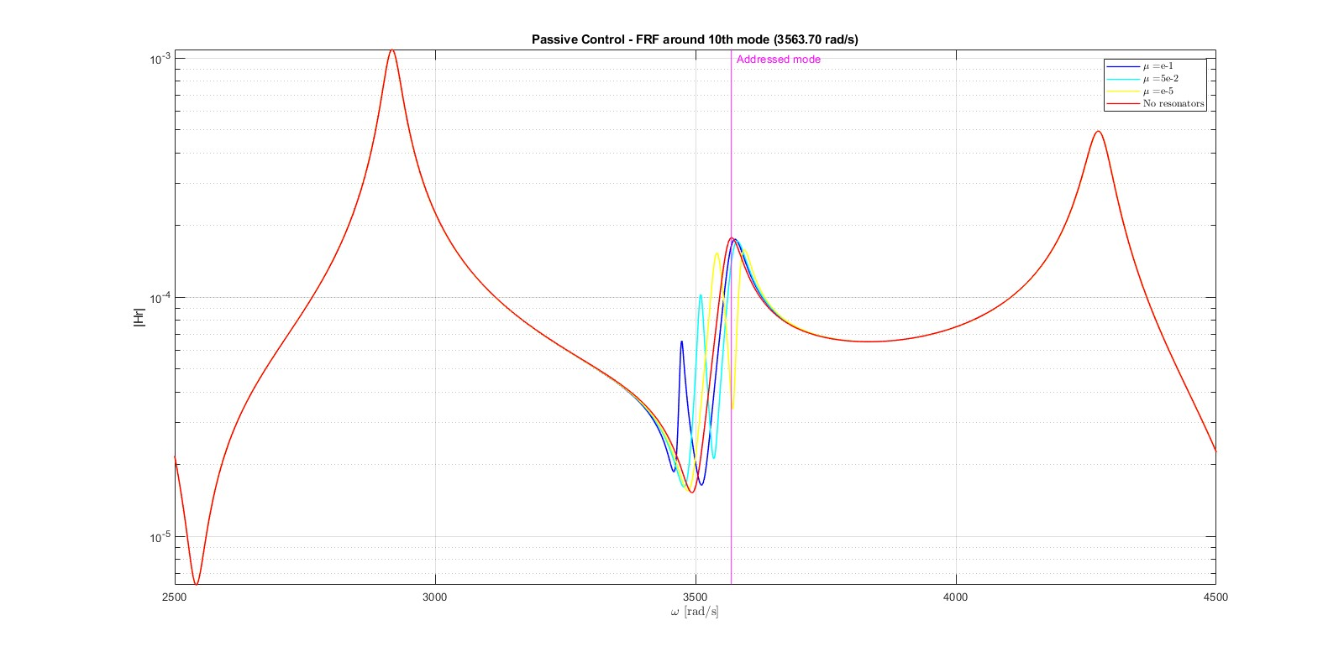

For the presented mass-ratio values, also in this case, the situation of the adjacent resonance peaks is practically the same.

*Proposed tune-mass dampers*

From the two upper analysis, the following values for the tune-mass dampers has been selected:

$$η=1{⸳10}^{-5} µ=5{⸳10}^{-5}$$

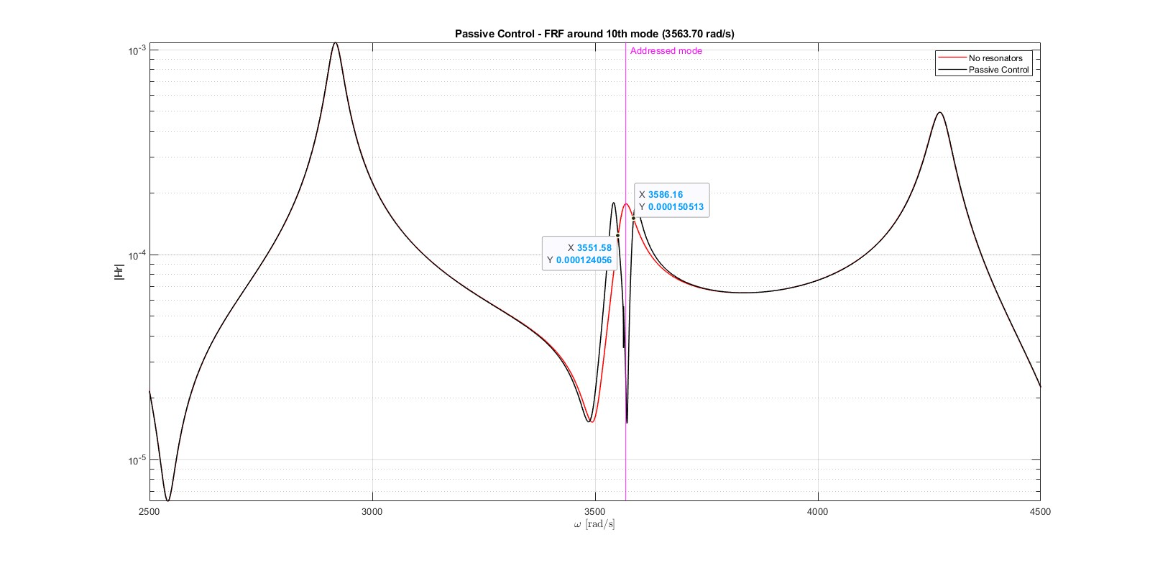

With this configuration we obtain:

* Resonators Frequency: $ω_{r}= 3563.66 rad/s$
* Resonators Adim. Frequency: $a_{r}=48.63$
* Resonators Stiffness: $k_{r}= 38.78 N/m$
* Added mass per tip mass: $m_{j}= 3.054 mg$

In conclusion, considering the control of the 10th resonance peak, a good result can be obtained for what concerns the attenuation for a very narrow range of frequencies (about 6 Hz). In the correspondence of the peak, we have now an attenuation equal to $2{⸳10}^{-5}$.

Increasing the number of resonators, opportunely placed, we can deform more the FRF and broaden the attenuation region.

A remark should be done on the fact that the control has been presented on a peak where in its surroundings the shape of the FRF is peculiar: considering a different pick-up point, better results can be shown with the same procedure.

*Single mode approximation*

This approximation is taken when we are in correspondence with the mode resonance frequency: in this case, the beam can be approximated by an effective stiffness and an effective mass. We will obtain the following state space representation where we can identify the eigenvalues:

$\dot{z}=Az, where z=\left[\begin{matrix}\dot{η} \\ \dot{u} \\ \begin{matrix}η \\ u\end{matrix}\end{matrix}\right] and A=\left[\begin{matrix}{-M}^{-1}C & {-M}^{-1}K \\ I & 0\end{matrix}\right]$

Where C, K are diagonal matrixes properly constructed.

These eigenvalues vary depending on the resonator parameters as show as follows.

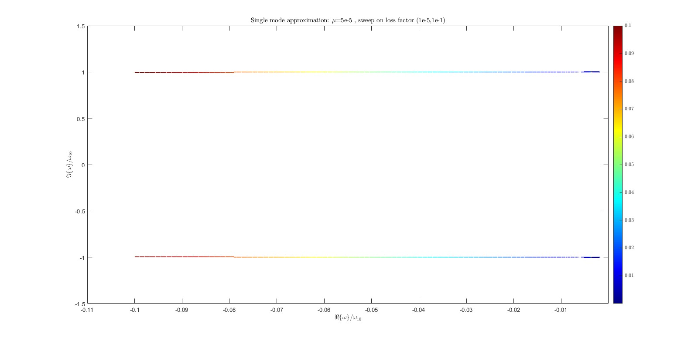

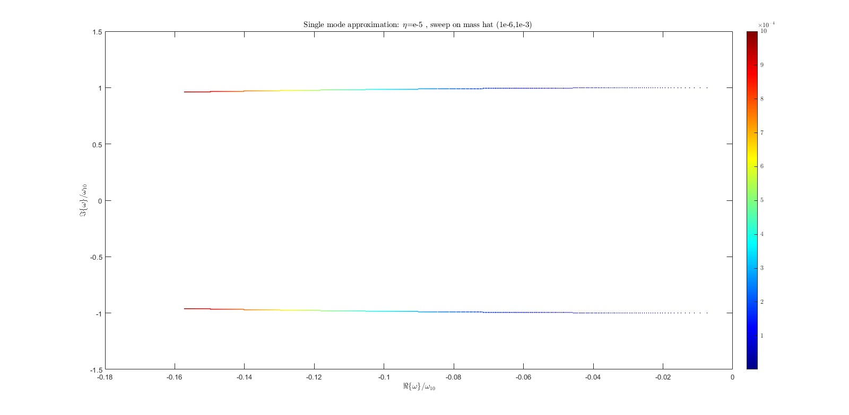

Employing this approximation, we can set targeted control strategies (e.g. pole placement, LQ-infinity control, ...). We observe that based on the chosen fixed value, the variation on the y-axis is not particularly relevant.

## Active control strategy – piezo patches

Different modes will be affected differently depending on the piezo patch position. The piezo patch must be placed to avoid an entire wavelength being exactly included in the piezo: in this case, the initial and final derivative are the same causing no piezo effect; To maximize the piezo effect, we want that the patch enclose exactly only half wavelength, hence the derivatives are equal and opposite.

We choose to control the 31th mode: 32073.31 rad/s (5104.63 Hz):

To maximize the piezo effect, we compute the derivative in the initial point and see where we have its opposite value. According to this, we identify the piezo length: ● $L_{p}=249mm$

As for the piezo width, we consider it the same as the beam one: ● $b_{p}=30.2mm$

Other relevant selected parameters are: ● piezo Young’s modulus: ${c^{E}}_{11}= 60.6{⸳10}^{9} Pa$

● piezo mass density: $ρ_{p}= 7500 kg/m^{3}$

● piezo constant: $e_{31}= -16.6 C/m^{2}$

● piezo permeattivity constant: ${e^{S}}_{33}= 25.59{⸳10}^{-9} F/m$

To decide the geometry of the piezo, during the design phase we keep constant the length $L_{p}$ and the width $b_{p}$ and we modify the thickness $h_{p}$. We notice that increasing the thickness of the piezo and keeping constant the other parameters, we increase the stifness and so reduce the number of peaks in the bandwidth of interest B1, whereas diminuishing it we decrease the stifness and so increase the number of peaks in this range.

With the goal to minimize the displacement, we select the piezo thickness equal to: $h_{p}=9.85mm$

The following results are reported considering different values of a resistance connected as electrical load. The resistance is a purely dissipative element, so it increases damping. We assume piezo patches series connected:

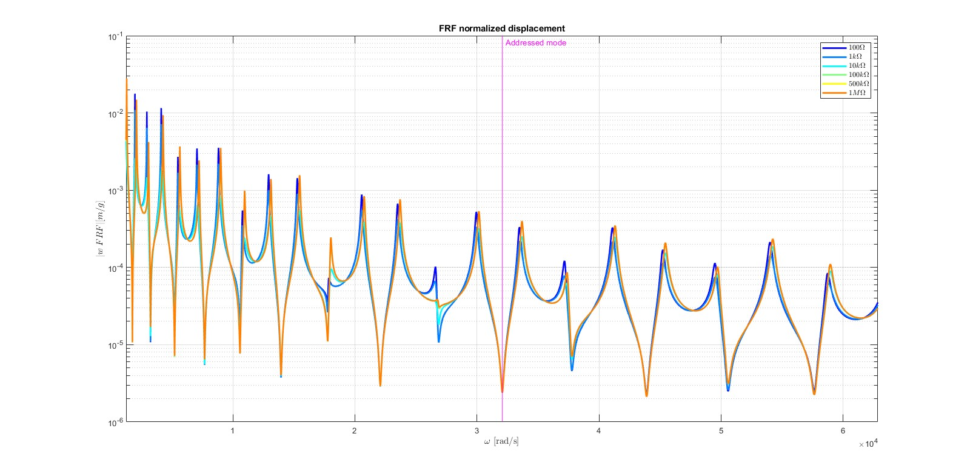

We notice that varying the electrical resistance, the displacement FRF are similar to each other.

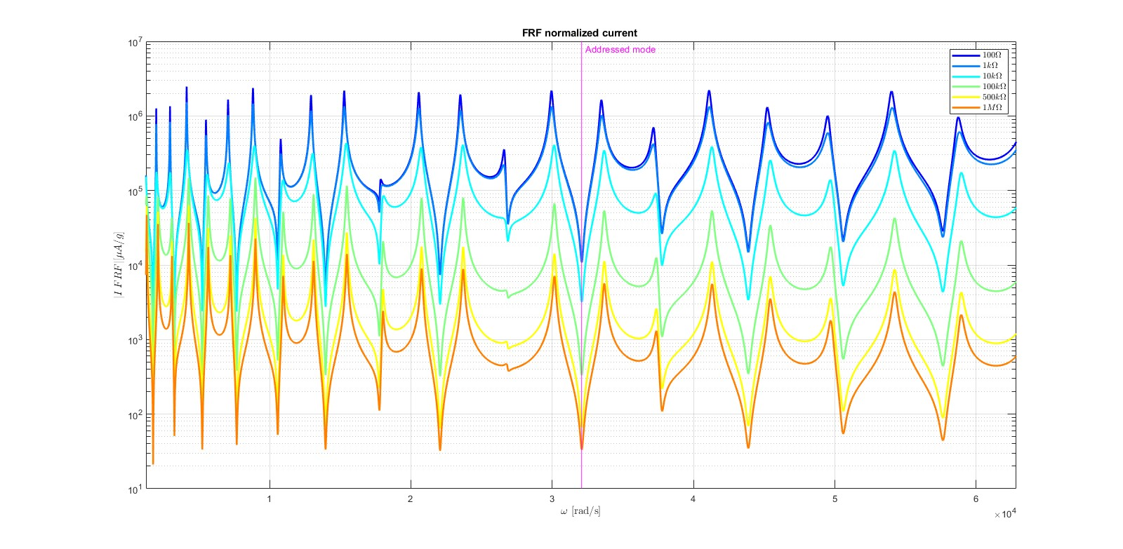

Increasing the resistance, the current FRF decreases. In the shortcircuit case (R=0), we have the maximum current. In the open circuit case (R → ∞), the minimum.

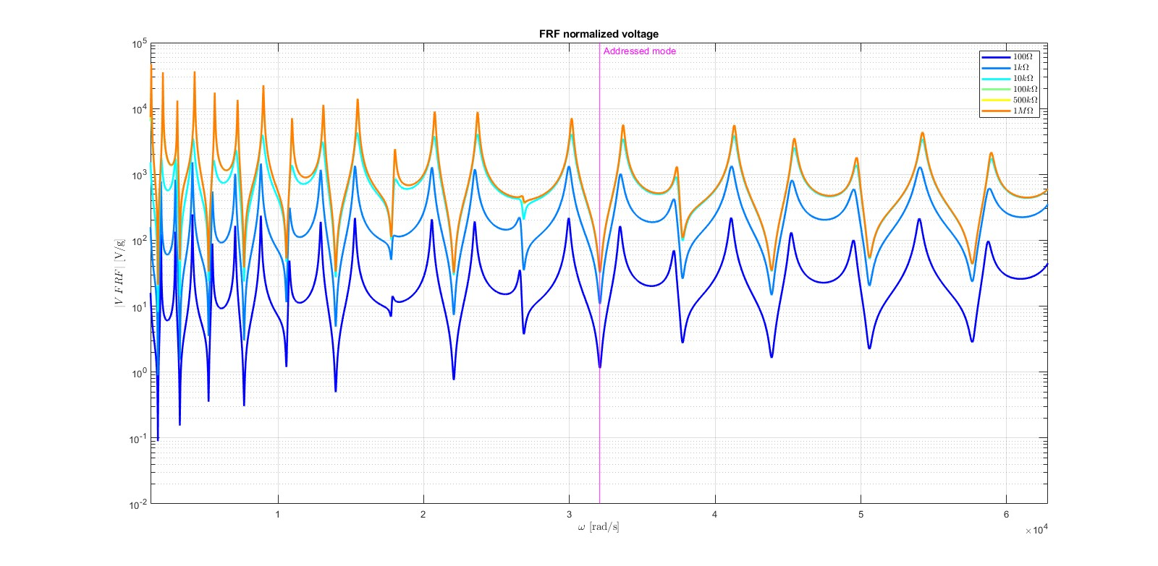

Increasing the resistance, the voltage FRF increases. In the shortcircuit case (R=0), we have the minimum voltage. In the open circuit case (R → ∞), the maximum.

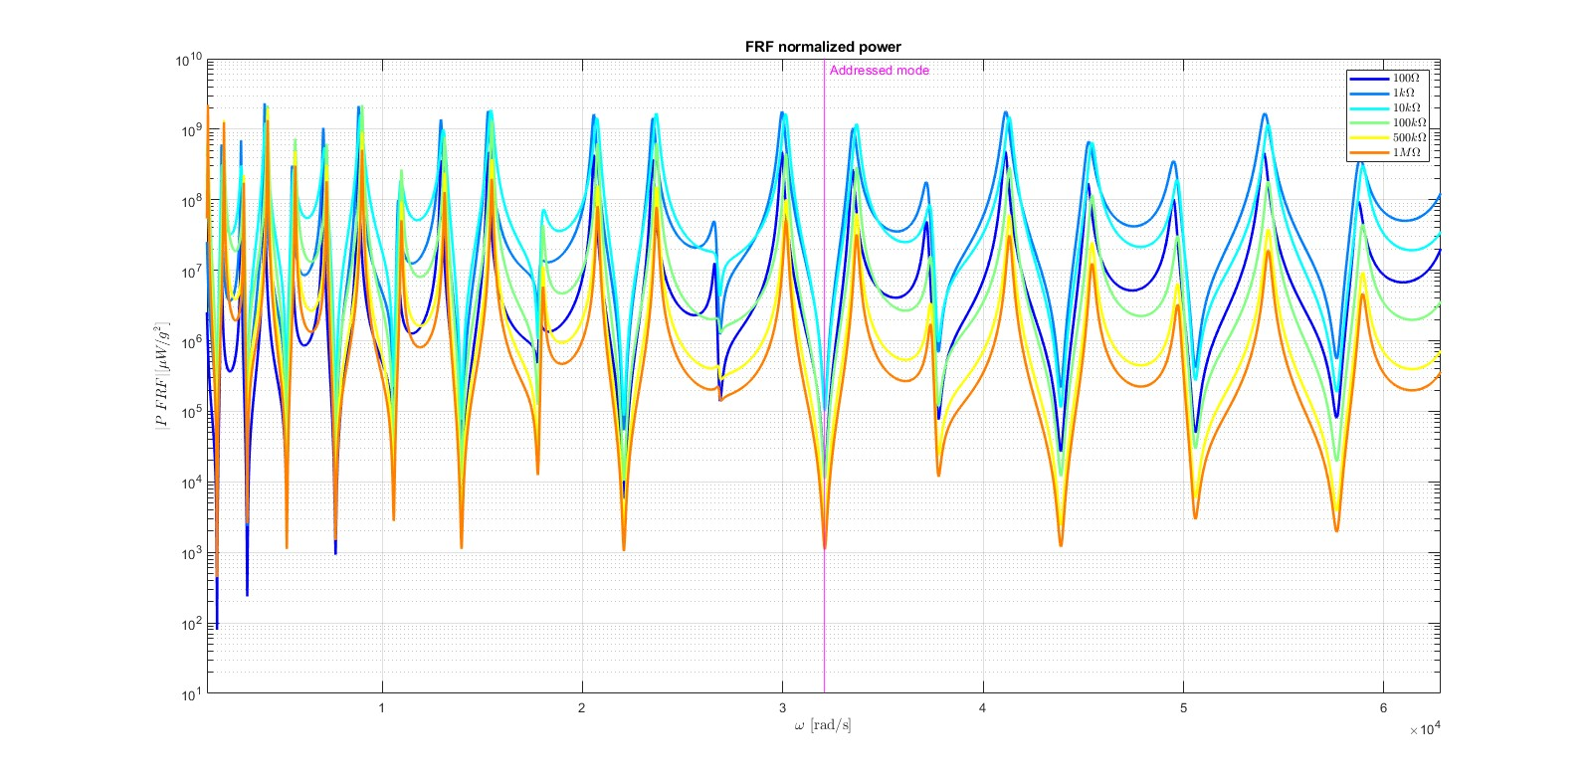

For the power FRF, we notice that the maximum is with an intermediate resistance between the shortcircuit and the open circuit case.

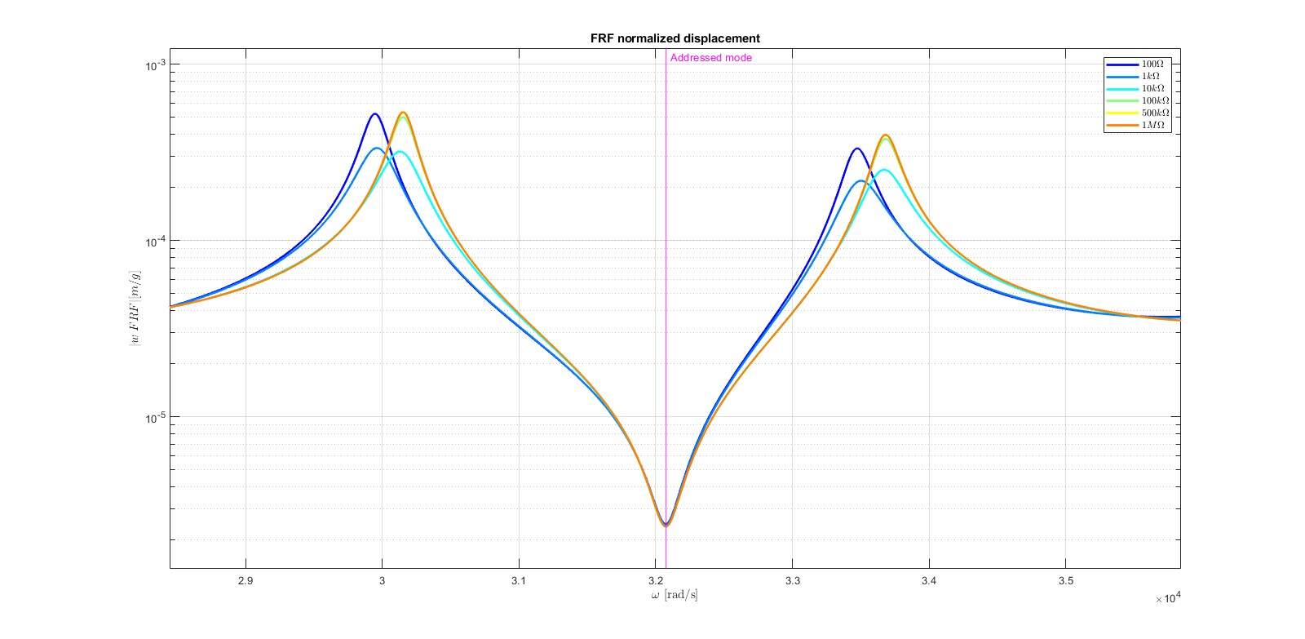

From the focus of the displacement FRF, we can notice that the more the resistance, the more the structure is stiff and so the peaks are shifted to higher frequencies.

In the reported FRF, it has been performed a normalization concerning the y-axis with the gravity acceleration.

With the piezos, using an imposed voltage as control input, we are able to modify the stiffness and the damping.

We remember that the electromechanical coupling factor in piezos is an important feature that describes both the flow from the mechanical side to the electrical side and vice versa.

For bandwidth B2, an analogous procedure can be applied, considering this time a FEM model to avoid the numerical issues associated with the analytical one.